Instructor’s Guide for Virtual Astronomy Laboratories
Mike Guidry, University of Tennessee Kevin Lee, University of Nebraska
The Brooks/Cole product Virtual Astronomy Laboratories consists of 20 virtual online astronomy laboratories (VLabs) representing a sampling of interactive exercises that illustrate some of the most important topics in introductory astronomy. The exercises are meant to be representative, not exhaustive, since introductory astronomy is too broad to be covered in only 20 laboratories. Material is approximately evenly divided between that commonly found in the Solar System part of an introductory course and that commonly associated with the stars, galaxies, and cosmology part of such a course.
Intended Use
This material was designed to serve two general functions: on the one hand it represents a set of virtual laboratories that can be used as part or all of an introductory astronomy laboratory sequence, either within a normal laboratory setting or in a distance learning environment. On the other hand, it is meant to serve as a tutorial supplement for standard textbooks. While this is an efficient use of the material, it presents some problems in organization since (as a rule of thumb) supplemental tutorial material is more concept oriented while astronomy laboratory material typically requires more hands-on problem-solving involving at least some basic mathematical manipulations.
As a result, one will find material of varying levels of difficulty in these laboratories. Some sections are highly conceptual in nature, emphasizing more qualitative answers to questions that students may deduce without working through involved tasks. Other sections, even within the same virtual laboratory, may require students to carry out guided but non-trivial analysis in order to answer questions. In this manual, we shall provide some information about choosing portions of laboratories for particular environments by classifying the sections of the VLabs according to three levels of difficulty, and by providing sample tracks through the material that would be appropriate for several different levels of course usage and student engagement.
Levels of Difficulty and Assorted Tracks
Each part of a VLab will be a assigned a level of difficulty according to the following criteria:
Beginner: Material is largely conceptual with little or no math required and no involved exercises.
Intermediate: Emphasis is still largely conceptual but exercises may contain
multiple steps and some math may be required. Any required math is often handled with special calculators.
Advanced: Exercise typically involves multiple steps. Required math is often handled by special calculators but students are expected to be able to use a standard calculator to do basic math where appropriate, with examples as reference.

In addition, for each VLab we shall designate four tracks through the material of that VLab according to the following criteria:
Virtual Astronomy Laboratories 2
Conceptual Track: Emphasis on concepts; consists of sections that are entirely of Beginner or Intermediate levels of difficulty. Exercises are limited in scope, little math is required, and what little there is will typically be handled by specialized calculators. This track is appropriate if one is using the Virtual Astronomy Laboratories as a textbook supplement for a non-majors course at the most introductory level.
Intermediate Track: Similar to the Conceptual Track, but with more emphasis on sections having Intermediate difficulty. Exercises may be somewhat more involved than on the Conceptual Track and more math will be required, although it will mostly be handled with specialized calculators. This track is appropriate if one is using the Virtual Astronomy Laboratories as a textbook supplement for a non-majors course, but wishes to challenge the students a little more than for the Conceptual Track.
Full Lab Track: This track utilizes the full range of exercises in the VLabs, including Beginner, Intermediate, and Advanced sections. Some exercises may involve multiple steps, math that must be done with a calculator, and an assumption that students must figure out some things on their own, given overall guidelines and worked examples. Some VLabs are longer than others and therefore instructors may wish to assign only portions of a full lab if the work is to be completed in say a single 3-hour session. Alternatively, the Full Lab Track for some VLabs may be broken into more than one laboratory assignment.
Abbreviated Lab Track: This track is similar to the Full Lab Track in spirit, but attempts to limit the suggested VLab sections to a subset that might fit into a single 3-hour laboratory session. This is only a guideline, since the instructor may construct her own Abbreviated Track by appropriate limitation of the Full Lab Track.
With these classifications as a guide, we hope that instructors will have sufficient information to tailor this material for a broad range of applications.
Web Retrieval of Data
One theme is to try to incorporate into each VLab exercises that require students to use the Web to obtain scientific information and then use that information as part of the exercises. We have managed to do that in many cases and these examples will be pointed out in the summary of each VLab. For example, several labs reinforce concepts through exercises that retrieve and use information from the SIMBAD database.
Data-Basing and Electronic Reporting
The Virtual Astronomy Laboratories are fully reportable electronically. Student answers are stored in a server database and used to construct formatted laboratory reports on demand. Instructors have the option of choosing to have students report or not report results. For those choosing to have students report results, the instructor has the option of specifying that the students print the lab reports to turn in, or have the reports reported

to the instructor electronically. If the latter option is chosen, the instructor may access each student report on demand through a web browser (with pages password protected). For instructor reports, the correct answers (where appropriate) may be included along with the student answers, if the instructor so chooses. (This is a useful option because in many exercises the particulars are generated randomly, so the correct answers may change from student to student.) Generally, the instructor must set up lab-reporting preferences for a class through an interactive page before instructor lab reports will be generated. The detailed instructions for setting up and administering electronic reporting are given in the Web pages associated with electronic reporting for adopting instructors (see http://val.brookscole.com).
Virtual Astronomy Laboratories 3
Virtual Laboratory Table of Contents
The top-level table of contents is summarized below
- Measurement and Unit Conversion
- Properties of Light and Its Interaction with Matter
- The Doppler Effect
- Solar Wind and Cosmic Rays
- Planetary Geology
- Tides and Tidal Forces
- Planetary Atmospheres and Their Retention
- Extrasolar Planets
- Asteroids and Kuiper Belt Objects
- Helioseismology
- The Spectral Sequence and the HR Diagram
- Binary Stars
- Stellar Explosions, Novae, and Supernovae
- Neutron Stars and Pulsars
- General Relativity and Black Holes
- Astronomical Distance Scales
- Evidence for Dark Matter
- Active Galactic Nuclei
- The Hubble Law
- Fate of the Universe
A more detailed site map containing the individual sections of each VLab may be found in Appendix A.
Summary of Virtual Laboratory Content and Usage Guidelines
In this section we summarize the main parts of each virtual laboratory, assign to each part a difficulty scale (Beginner, Intermediate, or Advanced, according to criteria listed above) and state learning objectives for each lab. In addition, we give suggested content for Conceptual, Intermediate, Full Laboratory, and Abbreviated Laboratory tracks (these tracks were also defined above). The VLabs are largely independent of each other, but in a few cases it is assumed within a VLab that students are familiar with material contained in another VLab (for example, many VLabs assume a knowledge of units conversion at the level covered in VLab 1). Where appropriate, we note any dependency of the lab in question on content for other VLabs. Note that each lab begins

with a set of instructions and ends with a summary and a short quiz over the material of the lab. Since these are common to all labs, they will not be listed explicitly in the following descriptions.
Virtual Astronomy Laboratories 4

VLab 1: Measurement and Unit Conversion
Virtual Astronomy Laboratories 5
This laboratory concerns itself primarily with why we need different units, how to convert between units, and with the use of scientific notation.
- Introduction gives a qualitative explanation of why use of different units can be important, examples of simple unit conversion, and some exercises that require students to make measurements and express answers in particular units. Difficulty: Beginner/Intermediate.
- Chart Conversions uses a Cepheid variable light curve and a plot of sunspot frequency to illustrate conversion of distances on a graph into physical quantities. Difficulty: Intermediate.
- Scientific Notation illustrates the use of scientific notation and the conversion between decimal and scientific notation. Difficulty: Beginner.
- Learning about Units is largely conceptual, illustrating some commonly used distance units and units of angular measure. Difficulty: Beginner.
- Arcs and Small Angles introduces the radian as a unit of angular measure and contains a more involved exercise that requires students to use the measured angular diameters of some planets to determine their physical diameters. This exercise requires students to retrieve data from Web resources and to use these data in determining planetary diameters. The conversion from arcseconds to radians is handled by a specialized calculator but students are expected to solve S = ra for the diameter (approximated by the arc-length S) using a calculator once the quantities are tabulated. A screen shot of this exercise is shown in Fig. 1.1 below. Difficulty: Advanced.
Learning Objectives: Students completing this laboratory should have a basic understanding of the importance of units and of appropriate choice of units, how to convert from one unit to another, the use of scientific notation, and how basic trigonometry may be used to infer physical diameters from angular diameters. Students will also gain experience using the Web to obtain and utilize basic astronomical information. Various other VLabs will assume that students are familiar with the units conversion techniques and scientific notation illustrated in this lab, so many other labs will list this lab as a dependency.
Dependencies on other Labs: None. Conceptual Track: Sections 1, 3, and 4. Intermediate Track: Sections 1—4. Full Lab Track: All sections.
Abbreviated Lab Track: Sections 1—4 or 1, 4, 5.

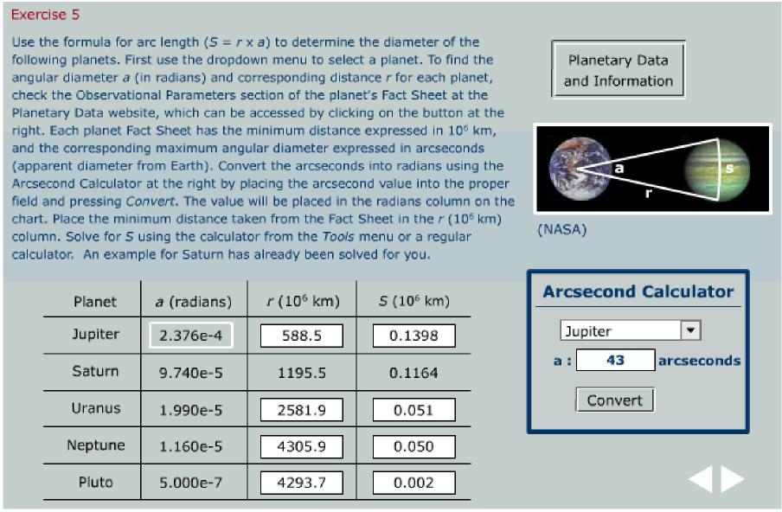
Figure 1.1 Screen shot of Exercise 5 from VLab 1. In this exercise, students are required to fill out the table by retrieving data from the Web on planetary angular diameters (the button at the upper right) and using these data to determine the diameters of the planets. A special calculator is provided for the arcsecond-to-radian conversion since students have been required in an earlier exercise to demonstrate their ability to perform this conversion manually. The final column is calculated by the student using S ~ ra. One example (Saturn) has been worked for the student. This is rated an advanced exercise because it requires some initiative to retrieve the data from a Web page containing much additional information, because of the basic math required, and because multiple steps are required to find the diameter of each planet.
Virtual Astronomy Laboratories 6

VLab 2: Properties of Light and Its Interaction with Matter
Virtual Astronomy Laboratories 7
This laboratory introduces the electromagnetic spectrum, regions of the spectrum, the Planck and Wien laws for blackbodies, and basic atomic structure and its relation to emission and absorption of radiation.
- The Electromagnetic Spectrum gives a conceptual introduction to electromagnetic waves and the electromagnetic spectrum. Difficulty: Beginner.
- Radiation Laws introduces the concept of a blackbody and the Planck and Wien radiation laws. Students use an interactive plotter (Fig. 2.1) to investigate the consequences for the radiation wavelength distribution of varying the temperature. Difficulty: Beginner.
- In Modeling Stars as Blackbodies, students use an interactive plotter (Fig. 2.1) to investigate the consequences of varying the temperature on the blackbody distribution and are asked to relate the peak of the spectrum to particular regions of the electromagnetic spectrum. Difficulty: Beginner/Intermediate.
- Light and Matter at Atomic Scales introduces basic atomic structure and relates absorption and emission of electromagnetic radiation to that structure. Students use an interactive atom builder (Fig. 2.2) to build atoms and ions subject to the rules of atomic physics. Difficulty: Beginner/Intermediate.
Learning Objectives: Students completing this laboratory should have a basic understanding of what electromagnetic waves and the electromagnetic spectrum are, the primary regions of the spectrum, and how the Planck and Wien laws describe the behavior of stars viewed as blackbody radiators. Students also should assimilate the basic rules of atomic structure through interactive building of atoms and ions from their constituent protons, neutrons, and electrons.
Dependencies on other Labs: None
Conceptual Track: All sections.
Intermediate Track: All sections.
Full Lab Track: All sections.
Abbreviated Lab Track: Sections 1—3 or 1, 2, 4.

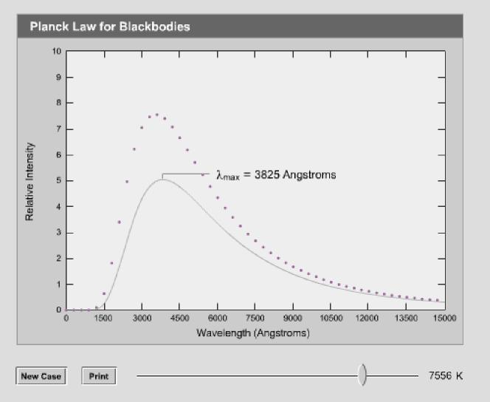
Figure 2.1 Screen shot of the Planck and Wien law plotter from VLab 2. This plotter shows the shape of the intensity curve as a function of wavelength, and the wavelength for maximum intensity, as the temperature is varied. It is used for several exercises in VLab 2.
Virtual Astronomy Laboratories 8
Figure 2.2 The atom builder tool of VLab 2. The student is building a carbon-12 atom and has just violated the Pauli principle by trying to add the next electron to a filled level.
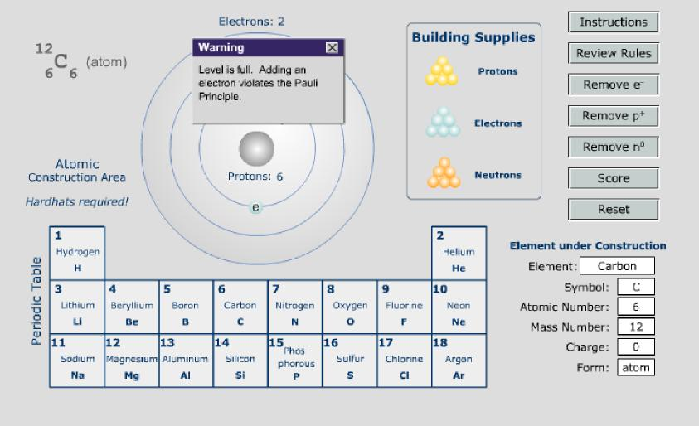

VLab 3: The Doppler Effect
Virtual Astronomy Laboratories 9
This lab provides a general introduction to the Doppler effect, first for sound waves and then for light waves.
- Introduction gives a conceptual introduction to the Doppler effect. Difficulty: Beginner.
- Wave Properties introduces waves, wavelength, frequency, period, and appropriate units for these quantities. Difficulty: Beginner.
- Sound As a Wave uses familiar experience with sound to illustrate various wave effects and introduces the Doppler effect as a change in the pitch of sound produced by relative motion between source and listener. Difficulty: Beginner.
- Doppler Effect: Sound introduces the formulas for the change in frequency caused by the Doppler effect for approaching and receding sources. Students are asked to solve various Doppler effect problems for sounds using a Doppler calculator. Difficulty: Intermediate.
- Light As a Wave introduces the idea that light behaves like a wave and that therefore light experiences a Doppler shift when source and detector are in motion relative to each other. Difficulty: Beginner.
- Doppler Effect: Light introduces the formula for the non-relativistic Doppler shift, implements several warmup problems about Doppler shifts, simulates a Doppler wave pattern and has students determine shifts by direct measurements on the wave pattern (see Fig. 3.1), has students compute the radial velocity for several real stars given the observed H-alpha line, and finally guides students in retrieving data from the SIMBAD database to compare their computed velocity with the radial velocity tabulated in SIMBAD (Fig. 3.2). Difficulty: Advanced.
Learning Objectives: Students completing this laboratory should have a basic understanding of the Doppler effect for sound waves, the Doppler effect for light waves, and how to determine the radial velocity of a star from shifts of spectral lines caused by relative velocity of the star. Students also gain experience using online astronomy databases (SIMBAD in this case) to check their results.
Dependencies on other Labs: VLab 1 for unit conversion.
Conceptual Track: Sections 1—5.
Intermediate Track: Sections 1—6.
Full Lab Track: All sections.
Abbreviated Lab Track: Sections 1, 2, 3, 5, 6.

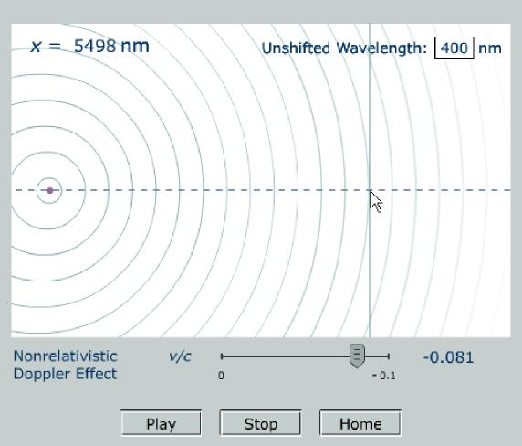
Figure 3.1 Non-relativistic Doppler shift exercise from VLab 3. Students simulate the wave pattern for a given radial velocity (set by the slider) and then measure the wavelength shift using a crosshair readout and compare the velocity deduced from that to the simulation velocity.
Virtual Astronomy Laboratories 10
Virtual Astronomy Laboratories 11
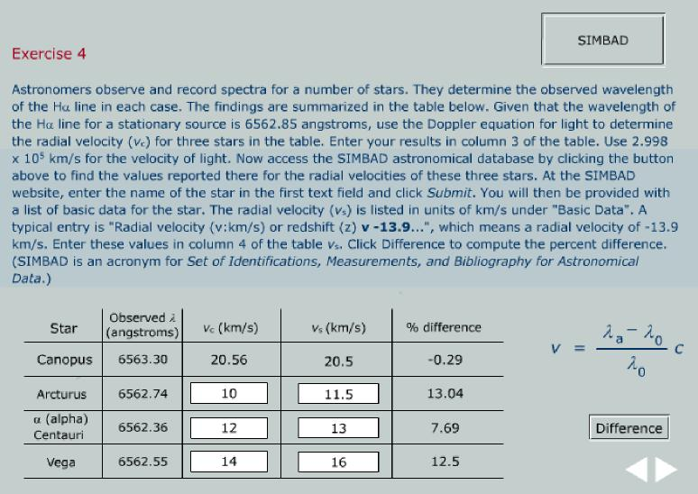
Figure 3.2 Exercise from VLab 3 to calculate the radial velocity of a star from the observed position of the H-alpha line and to compare the result with the radial velocity tabulated in the SIMBAD database.
VLab 4: Solar Wind and Cosmic Rays
This lab investigates the types of particles that travel to the Earth from the Sun and their interaction with the Earth’s magnetosphere. Higher energy particles from supernovae and ultra high energy cosmic rays whose source is unknown are also covered.
- Introduction simply notes that space is filled with particles traveling at high velocities. Some of these (like those coming from the Sun) are well-understood, while the source of others (such as very high energy cosmic rays) is unknown. Difficulty: Beginner.
- Solar Wind introduces the three layers of the solar atmosphere and the very high temperature of the corona, which allows particles to escape from the Sun. A simulated detector (see Fig. 4.1) allows students to collect particles from the solar wind and compare the relative abundances of nuclei. Difficulty:
Intermediate.
- The Earth’s Magnetosphere describes the deflection of the charged solar wind particles as they near the Earth. Students work with the right-hand rule and are asked to determine the deflection of protons, neutrons, and electrons in various magnetic field orientations. Difficulty: Intermediate.
- Cosmic Rays covers the values of the flux and energy of cosmic rays (see Fig. 4.2) and some of the ground-based experiments to detect air showers. Students will view simulated air showers from ground-based detectors and estimate the direction of incidence and energy of the primary cosmic ray. Difficulty: Beginner.
- UHECR focuses on the most energetic cosmic rays that are detected very infrequently and discusses some possible mechanisms for their creation. Difficulty: Beginner.
Learning Objectives: Students completing this laboratory should have a basic understanding of the characteristics of cosmic rays and how scientists study them. They should also understand the deflection of charged particles in a magnetic field.
Dependencies on other Labs: None Conceptual Track: Sections 1—5. Intermediate Track: Sections 1—5. Full Lab Track: Sections 1-5. Abbreviated Lab Track: Sections 1 - 4.

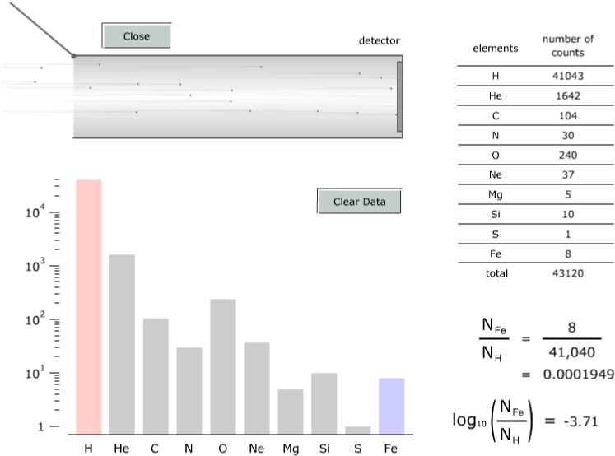
Figure 4.1 The Solar Wind Detector allows students to collect simulated samples of the solar wind and compare the relative abundances of common nuclei in the sample.
Virtual Astronomy Laboratories 12
Figure 4.2 Screenshot of an interactive diagram illustrating cosmic rays fluxes and energies with easily understood comparisons.
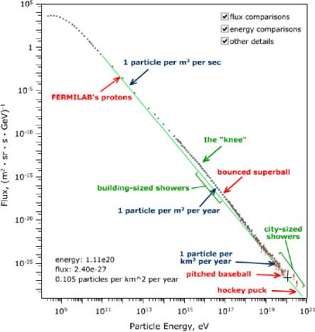

VLab 5: Planetary Geology
Virtual Astronomy Laboratories 13
This lab illustrates how seismology allows us to learn about the interior of the Earth. Characteristics of the interior layers of the Earth are surveyed as well as the violent manifestations we see on the surface – earthquakes and volcanoes.
- Introduction motivates the thinking behind comparative planetology – we should start with the Earth since it is the planet we know best. We can then most efficiently learn about other planets by comparing and contrasting them with the Earth. Difficulty: Beginner.
- Seismology first motivates the study of the interior of the Earth by noting the obvious evidence for differentiation. The characteristics of seismic waves and what we can learn from them are then summarized. Difficulty: Beginner.
- Interior of the Earth discusses how we learn about the interior of the Earth and its four distinct regions. Students actively learn about the characteristics of the interior of the Earth with the Earth Explorer (see Figure 5.1) and then apply seismology concepts to a simulated planetary interior in the Planetary Interior Exercise. Difficulty: Intermediate.
- The Earth’s Surface discusses the manifestations we can observe of the activity in the Earth’s interior. Continental drift, earthquakes, and volcanism are all covered (see Figure 5.2). Difficulty: Intermediate.
- Other Solar System Bodies compares the Earth to other terrestrial planets and the Moon. We focus on those geological aspects of the Earth that have been discussed in earlier sections. Difficulty: Beginner.
Learning Objectives: Students completing this laboratory should have a basic understanding of how seismologists learn about the Earth and the characteristics of the four regions of the Earth’s interior. They will also learn how processes in the Earth’s interior lead to continental drift, volcanism, and earthquakes. Students will obtain a brief introduction to comparative planetology and should be able to describe some of the ways in which the Moon, Mercury, Venus, and Mars differ from the Earth.
Dependencies on other Labs: None. Conceptual Track: All sections. Intermediate Track: All sections. Full Lab Track: All sections. Abbreviated Lab Track: Sections 1—4.

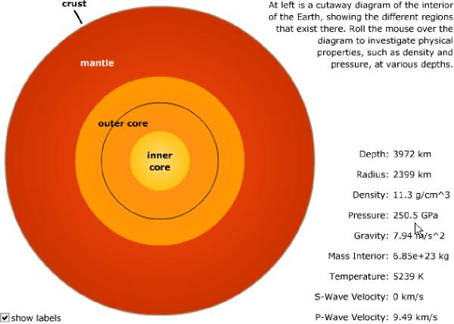
Figure 5.1 The Earth Explorer allows students to learn about the characteristics of each region of the Earth’s interior.
Virtual Astronomy Laboratories 14
Figure 5.2 The Plate Tectonics Explorer allows students to see the relationship between the location of volcanoes, earthquakes, and plate boundaries.
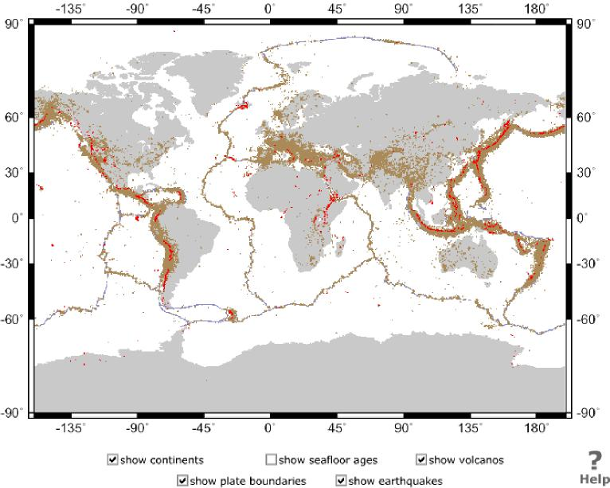

VLab 6: Tides and Tidal Forces
Virtual Astronomy Laboratories 15
Virtual Astronomy Laboratories 16
This lab investigates the origin of gravitational and tidal forces, and the role of the Sun and Moon in tidal forces experienced on Earth. The importance of tidal forces in a broader astronomical context is introduced through the Roche limit and its implications.
- Gravitational Forces introduces the basics of the gravitational force and of differential gravitational forces (tidal forces). This section then guides students in the calculation of relative gravitational and tidal forces exerted on the Earth by the Moon and the Sun, respectively. Students are then asked to explain from their results why the tidal influence of the Moon is larger even though the Sun’s gravitational force is clearly dominant. Difficulty: Intermediate/Advanced
- Lunar and Solar Tidal Effects discusses various aspects of tides in the Earth’s oceans. Students are asked to use the Web to retrieve tidal data from the National Ocean Service and to relate spring and neap tides observed at Juneau, Alaska, to phases of the Moon on particular dates (which students retrieve over the Web from the U. S. Naval Observatory). See Fig. 6.1. Difficulty:
Intermediate.
- The Roche Limit introduces the Roche limit conceptually and a calculator to determine the Roche limit in various circumstances. Students are asked to use this calculator to answer a variety of questions concerning the influence of the quantities that enter the Roche limit equation (see Fig. 6.2 for an example). Difficulty: Intermediate.
Learning Objectives: Students completing this laboratory should have a basic understanding of the difference between gravitational forces and differential gravitational or tidal forces, and an understanding of why both the Sun and Moon exert tidal forces on the Earth but that of the Moon is more important. Students obtain experience in obtaining data from the Web to solve a practical problem (relating spring and neap tides to the phase of the Moon) and are introduced to the broader issue of tides in astronomy through investigation of the Roche limit.
Dependencies on other Labs: None. Conceptual Track: Sections 1—3. Intermediate Track: Sections 1—3. Full Lab Track: All sections.
Abbreviated Lab Track: Sections 1—2.
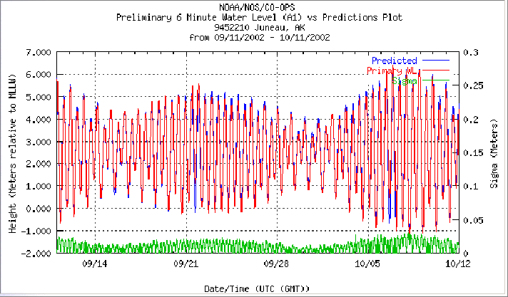
Figure 6.1 National Ocean Service tidal data from Juneau, Alaska, obtained over the Web and used by students in a VLab 6 exercise.
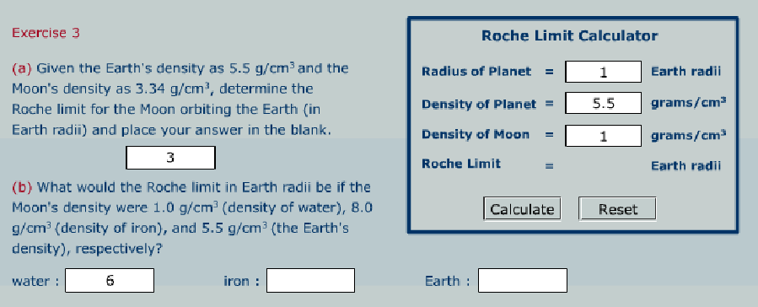
Figure 6.2 The Roche limit calculator and a portion of an exercise in VLab 6 dealing with tidal forces and the meaning of the Roche limit.

VLab 7: Planetary Atmospheres and Their Retention
Virtual Astronomy Laboratories 17
This lab investigates the factors that govern whether a planet can retain an atmosphere.
- Introduction discusses the basic factors that determine whether an astronomical body like a planet can keep an atmosphere: temperature, mass of the planet, mass of molecules in the atmosphere, and whether it has a magnetic field to shield the atmosphere against the solar wind. Difficulty: Beginner.
- Ideal Gases introduces the ideal gas law as a standard description of gas behavior under many conditions in astronomy. Students are required to work a simple gas law problem with an example given as a guide. Difficulty: Intermediate/Advanced.
- The Maxwell Distribution introduces the kinetic theory of gases as governed by the Maxwell speed distribution. An interactive plotter (see Fig. 7.1 below) permits the Maxwell distribution to be investigated as function of temperature and the mass of the molecules in the gas. An interactive simulation of particles in a box with a Maxwell distribution and reflecting walls permits further investigation of the speed distribution as a function of temperature. Difficulty: Intermediate.
- Escape Velocity introduces the importance of gravity for retention of
atmospheres. Students use an escape velocity calculator to investigate escape velocity for various objects in the Solar System. A simulation of gas molecules in a box with an open top and a gravitational field facilitates a series of exercises that give experience with how temperature, mass of atmospheric molecules, and escape velocity conspire to determine which gases can be retained and which will be lost over large timescales (see Fig. 7.2). Difficulty: Intermediate.
- Velocity vs. Temperature ties together the information gleaned from the interactive exercises in parts 2—4 and tests the student’s understanding through a set of qualitative and essay questions about retention of atmospheres. Difficulty: Intermediate.
Learning Objectives: Students completing this laboratory should have a good grasp of how atmospheric temperature, strength of gravitational field, and mass of atmospheric molecules influence the retention of an atmosphere by a planet or other astronomical body. (The role of a magnetic field is mentioned as a secondary influence, but is not dealt with explicitly in any of the exercises.)
Dependencies on other Labs: VLab 1 for units conversions.
Conceptual Track: Sections 1, 3, 4, 5.
Intermediate Track: Sections 1, 3, 4, 5.
Full Lab Track: All sections.
Abbreviated Lab Track: Sections 1—4.

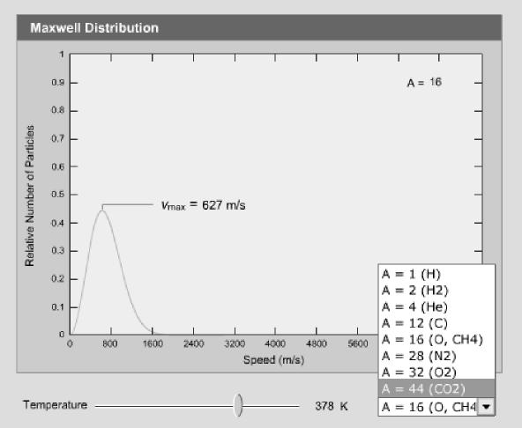
Figure 7.1 The Maxwell speed distribution calculator and plotter used in VLab 7. Students may choose the mass of the gas molecule from the popup window and set the temperature with the slider. The corresponding speed distribution and the most likely speed are displayed as the temperature is varied.
Virtual Astronomy Laboratories 18
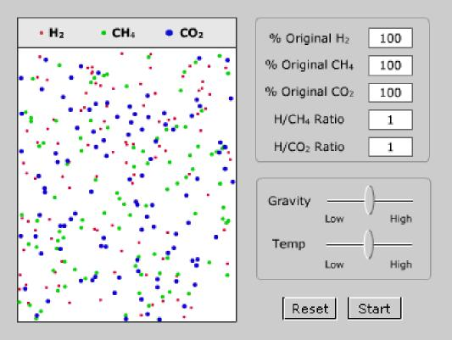
Figure 7.2 Simulator used in VLab 7 for gases with Maxwell distributions in a box that reflects on the bottom, left, and right sides, but is open at the top, with a gravitational field acting in the downward direction. The gas is a mixture of three different molecules with different molecular weights. Students control the relative temperature and strength of gravity with the sliders. Gas molecules that reach the top of the container are allowed to escape, and the display fields on the upper right keep track of how many molecules of each type are retained and how many escape. This simulator permits the factors of atmospheric temperature, strength of gravitational field, and mass of molecules in the atmosphere to be investigated simultaneously by students in order to understand how these factors have determined the currrent atmospheres of the planets.

VLab 8: Extrasolar Planets
Virtual Astronomy Laboratories 19
This lab investigates the evidence for, methods of discovery, and implications for planetary theory, of extrasolar planets.
- Introduction summarizes some of the extrasolar planets that have been discovered to data. Difficulty: Beginner.
- Doppler Wobble is a long section that goes into some detail concerning the Doppler method for inferring the existence of extrasolar planets and their mass functions. Students are first given some simple exercises to determine the location of the center of mass. We then introduce a small-angle calculator and use it to take students through an exercise indicating how small the angular wobble induced on the parent star by a Jupiter-like companion is. The Doppler wobble method is then introduced, first conceptually, and then through a completely worked interactive example (see Fig. 8.1). After this, students are guided step-by-step through an exercise in which they repeat this Doppler wobble analysis for 51 Pegasi, ultimately determining the mass function for its planetary companion (see Fig. 8.2). Difficulty: Advanced.
- Planetary Transits describes how in favorable situations an extrasolar planet may transit the face of its parent star as viewed from Earth, and discusses the wealth of additional information that this implies beyond what can be learned from Doppler wobble measurements alone. Students then analyze the light curve of the transit that has been observed for HD209458 and couple that with
information from the Doppler measurements to determine the mass, diameter, and density of the transiting planet. Difficulty: Advanced.
- “Hot Jupiter” Problem introduces the puzzle that many extrasolar planets appear to be “hot Jupiters”: gas giants very near their parent star. Students are asked to use the information that they deduced in the preceding section from the transit of HD209458 to determine whether the companion is a gas giant and whether it is a “hot Jupiter”. Difficulty: Intermediate.
- Web Exercise obtains extrasolar planet data from the Web and uses an orbit animation tool to construct an animated “fantasy” solar system containing several known extrasolar planets and some representative planets from our own Solar System, as illustrated in Fig. 8.3 (we assume that the mass of all central stars is 1 solar mass in this construction, which is approximately true; we also for simplicity assume all planets to move in the same plane with prograde motion). This exercise conveys strikingly the fundamental difference between the location of gas giants within our own Solar System and their location in many of the extrasolar systems that have been discovered so far. Difficulty: Intermediate.
Learning Objectives: Students completing this laboratory should appreciate the revolution underway in planetary astronomy because of the discovery of 100+ extrasolar planets. They should understand how remarkably precise the measurements must be to detect extrasolar planets, how the existence of an extrasolar planet and the value of its mass function may be inferred from its radial velocity curve, and how observation of a

planetary transit of the parent star by an extrasolar planet allows much more detailed
Virtual Astronomy Laboratories 20
information to be determined. Finally students should begin to appreciate the
implications of extrasolar planet observations through the planet-system building exercise that conveys graphically just how different the solar systems implied by the extrasolar planets found so far are when compared with our own Solar System.
Dependencies on other Labs: VLab 1 for units conversions; VLab 12 for Doppler effects in binary systems is also useful supplemental material, though not essential.
Conceptual Track: Sections 1, 4, 5. Intermediate Track: Sections 1, 3, 4, 5.
Full Lab Track: All sections. The material is clearly more than can be handled in a single laboratory session. An instructor wishing to cover all this material should allow at least two lab sessions.
Abbreviated Lab Track: Sections 1, 2, 5.
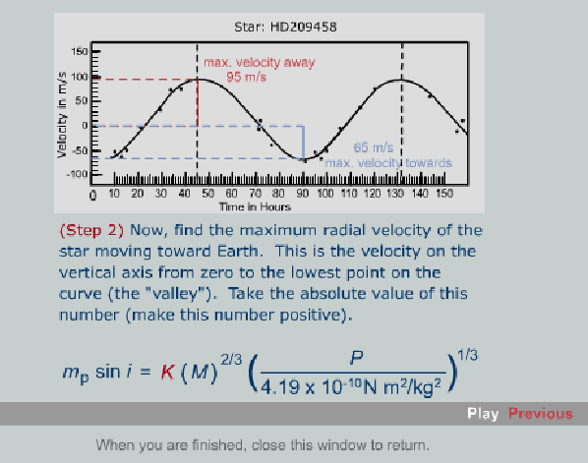
Figure 8.1 Interactive animation from VLab 8 giving step-by-step illustration of how the mass function for the planetary companion of HD209458 may be determined from the radial velocity curve. After this demonstration, students are asked to perform a similar analysis for the planetary companion of 51 Pegasi in one of the advanced exercises included in VLab 8 (see Fig. 8.2).

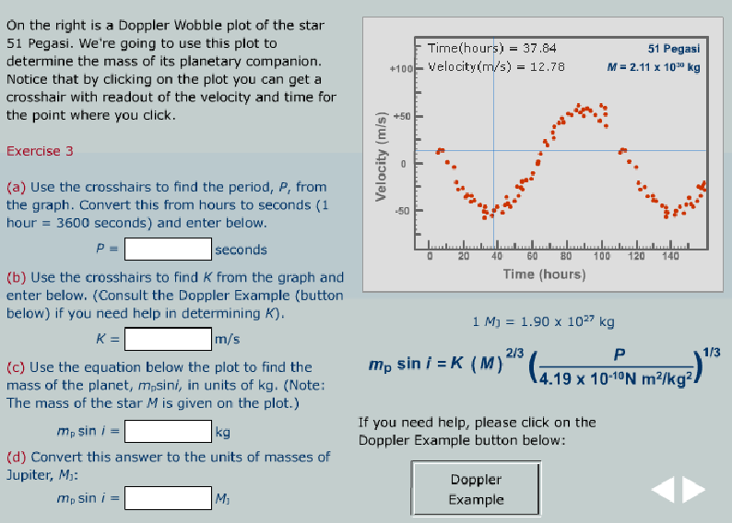
Figure 8.2 First steps of a systematic advanced exercise from VLab 8 in which students determine the mass function for the planetary companion of 51 Pegasi. By clicking on the button Doppler Example, students may review the example worked out earlier for HD209458 (see Fig. 8.1).
Virtual Astronomy Laboratories 21

Figure 8.3 The orbit builder tool used in VLab 8 to construct an animated imaginary solar system with some known extrasolar planets and some planets from our own Solar System orbiting the same (1 Solar mass) star. This system animates according to Kepler’s laws when Start is clicked and demonstrates graphically the differences between distribution of planets in our own Solar System and that discovered so far for extrasolar systems. For simplicity, we assume all planets to orbit in the same plane, in the same direction, and to start the animation with the same orbital phase in this exercise, since this information is not generally available for extrasolar planets. The orbit builder tool is a general purpose Kepler orbit animator that allows the user to build any gravitating system of objects in orbit around a central object. An instructor may thus use this tool to construct a number of other exercises that go beyond the specific ones given in this example. In VLab 18, we shall use the same orbit builder tool to construct the orbits for stars very near the central black hole of the Milky Way, for example. Click the Help button on the bottom row of buttons for a detailed description of how to use the orbit builder tool.
Virtual Astronomy Laboratories 22
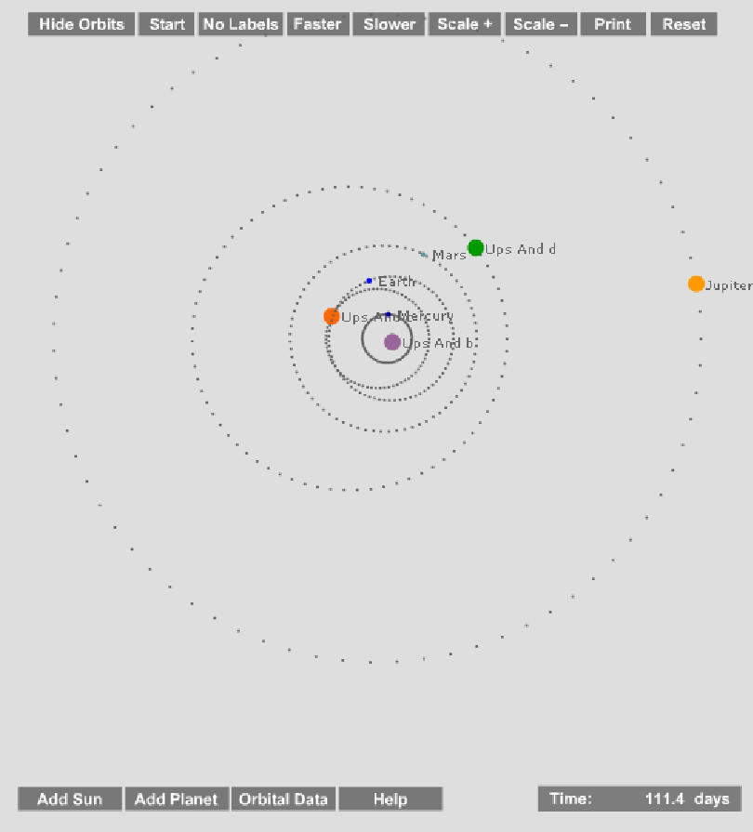

VLab 9: Asteroids and Kuiper Belt Objects
Virtual Astronomy Laboratories 23
This lab summarizes how astronomers learn about the characteristics of asteroids and Kuiper Belt Objects – discovery, orbits, sizes, albedo, and masses. Special emphasis is placed on the concept of resonance and how it determines the distribution of these objects.
- Introduction summarizes the characteristics of the Asteroid Belt and the Kuiper Belt. It is made clear that our knowledge of the Kuiper Belt has made great leaps in recent years. Difficulty: Beginner.
- Discovery uses a simulated blink comparator to identify an asteroid from actual CCD frames. The process is motivated by discussing Clyde Tombaugh’s discovery of Pluto. Difficulty: Beginner.
- Orbits reviews Kepler’s Laws and the significance of the semi-major axis and eccentricity. Calculations using Kepler’s 3rd law are emphasized. Difficulty: Intermediate.
- Resonance encourages students to identify the orbits where regular interaction with Jupiter (for asteroids, see Fig. 9.1) and Neptune (for KBOs) is occurring. Two special calculators are provided to assist them with the mathematical procedures. The coverage for KBOs is especially thorough as students will perform simulations of interaction with Neptune (see Fig. 9.2) and come to understand why the three different groups of KBOs occur. Difficulty: Intermediate.
- Albedo introduces students to the definitions of albedo and thermal equilibrium. The albedo is calculated for an asteroid using the ratio of visible and infrared flux. Once the albedo is known the size of an asteroid can be estimated. Difficulty: Advanced.
- Binaries applies Kepler’s 3rd Law to binary asteroids to calculate their combined mass. Individual masses are then estimated from their brightnesses. Difficulty: Advanced.
Learning Objectives: Students completing this lab acquire a qualitative understanding of the characteristics of asteroids and KBOs. They will gain considerable expertise in working with orbital parameters (semi-major axis and eccentricity) and performing calculations with Kepler’s 3rd Law.
Dependencies on other Labs: VLab 1 for units conversions.
Conceptual Track: Sections 1—3.
Intermediate Track: Sections 1—4.
Full Lab Track: All sections (although this could then easily be a two-period lab).

Abbreviated Lab Track: 1-4.
Virtual Astronomy Laboratories 24
Figure 9.2 The KBO simulator allows students to specify the semi-major axis and eccentricity of a Kuiper Belt Object and simulate its interaction with Neptune.
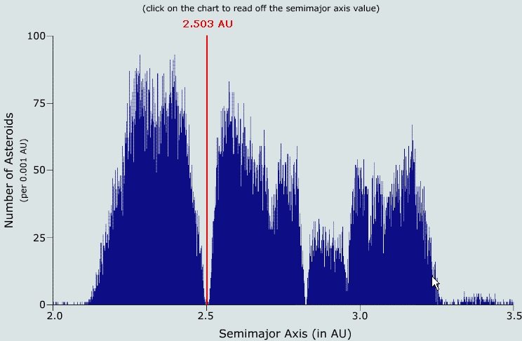
Figure 9.1 Students can explore the distribution of asteroids and identify the semi-major axes where resonances are occurring.
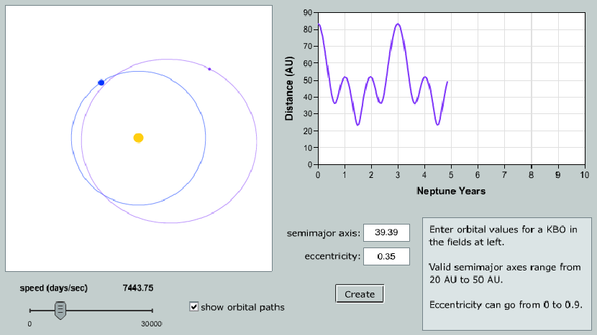

Lab 10: Helioseismology
Virtual Astronomy Laboratories 25
Virtual Astronomy Laboratories 26
Virtual Astronomy Laboratories 27
This lab investigates the methods of helioseismology and the information about the Sun that such methods may yield. Since any very rigorous discussion of helioseismology requires mathematics beyond the scope of an introductory astronomy course (surface harmonic series, for example) this VLab is somewhat more conceptual than most.
- Introduction motivates the discussion of helioseismology through a simple virtual experiment reminding students that the way things vibrate and produce sound waves is related to their internal structure (see Fig. 10.1). Difficulty: Beginner.
- Dopplergrams introduces students to the complex vibrations of the Sun and to the representation of those vibrations in terms of Doppler shift maps of the solar surface (Dopplergrams). The section begins by playing for students some sound files corresponding to solar vibrational modes transcribed to the audible range. Students then become familiar with Dopplergrams by using one to estimate the rotation speed of the Sun at various latitudes (see Fig. 10.2). Difficulty: Intermediate.
- Solar Oscillations is largely conceptual, describing qualitatively the concepts of convection, standing waves, propagation of waves, and sound speed, and their role in understanding the results of helioseismology. This section concludes with a short exercise investigating the deviation of interior sound speed determined through helioseismology from that predicted by the Standard Solar Model. Difficulty: Beginner.
- Solar Models uses helioseismology data to infer the detailed manner in which the Sun is rotating internally as a test of the Standard Solar Model (see Fig. 10.3). Difficulty: Intermediate.
Learning Objectives: Students completing this laboratory should have a qualitative understanding of how and why helioseismology works, of the kinds of information that detailed analysis of helioseismology can yield, and of how helioseismology is being used to test the Standard Solar Model.
Dependencies on other Labs: None. Conceptual Track: Sections 1—4. Intermediate Track: Sections 1—4. Full Lab Track: All sections.
Abbreviated Lab Track: All Sections.
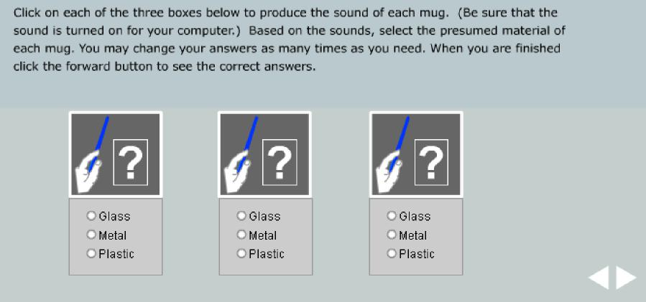
Figure 10.1 A simple virtual experiment from VLab 10 that reminds students of something from their own experience: the sound produced when objects vibrate tells us something about the composition of the object. The sounds played when the top box is clicked in each case were produced by striking coffee mugs made of three different materials.
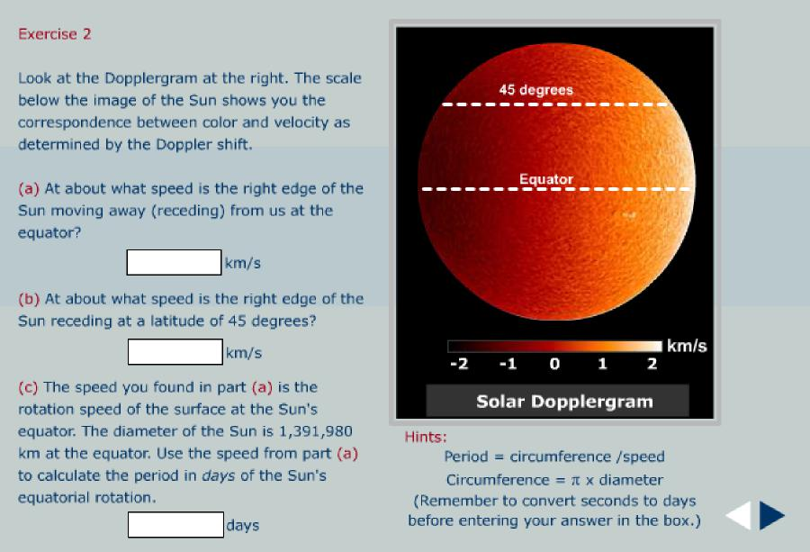
Figure 10.2 An exercise from VLab 10 in which students become familiar with solar Dopplergrams by using one to infer the rotational velocity of the Sun at different latitudes.
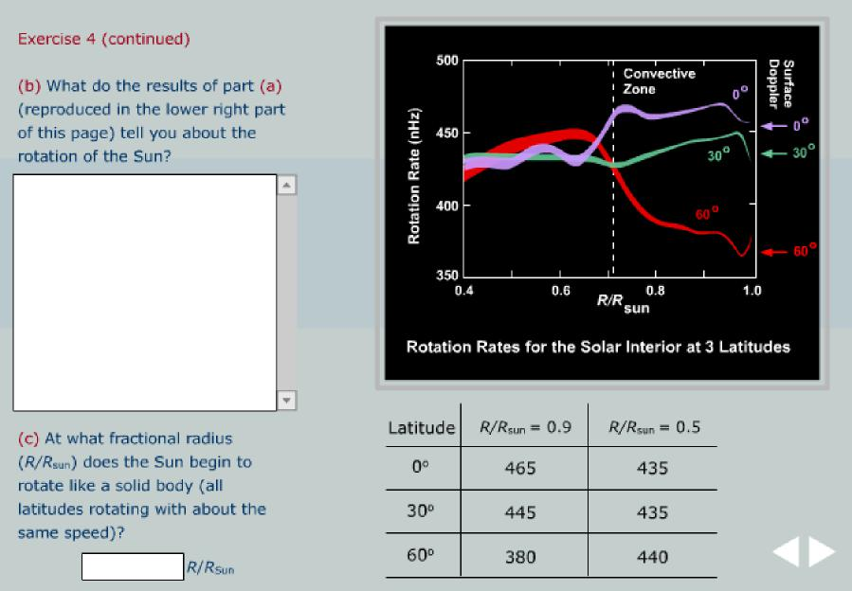
Figure 10.3 Concluding portion of an exercise from VLab 10 in which students use data from helioseismology to infer the internal rotation properties of the Sun. The data in the lower right table are reproduced from a table that was constructed in a preceding portion of the exercise and corresponds to rotation rates in nHz.

VLab 11: The Spectral Sequence and the HR Diagram
Virtual Astronomy Laboratories 28
This lab investigates how the Hertzsprung—Russell (HR) diagram systematizes stellar structure, how it may be used with certain assumptions to determine distances to clusters of stars, and how the distribution of stars in the HR diagram for a cluster is closely tied to an understanding of stellar evolution and is a measure of the age of the cluster.
- Introduction introduces surface temperature and its relation to spectral class, luminosity, apparent and absolute magnitude, distance modulus, color index, and the HR diagram. Difficulty: Beginner.
- Distance Modulus is a long section with several exercises that require students to construct HR diagrams for clusters and to determine the distance to the clusters by matching the main sequences of the cluster HR diagrams plotted using apparent magnitude against a standard main sequence. Examples are shown in Figs. 11.1 and 11.2. The three primary exercises involve HR diagrams for the Hyades,
Pleiades, and α Persei clusters, respectively. Although each is a worthwhile activity that emphasizes different aspects of the problem, there is considerable overlap among these three exercises and an instructor may wish to assign only one or two of them (for example, the Hyades example alone, or the Hyades example with either the Pleiades or α Persei example). Difficulty: Advanced.
- Main Sequence Lifetime discusses stellar evolution and how it influences the HR diagram for a cluster. Students are guided through an exercise to estimate the age of the cluster M3 by determining the location of the turnoff point for its HR diagram and comparing the spectral class corresponding to the turnoff point with expected main sequence lifetime for stars of that main sequence spectral class. Difficulty: Intermediate.
Learning Objectives: Students completing this laboratory should have a basic understanding of spectral classes, apparent and absolute magnitudes, color index, the HR diagram, the distance modulus, how matching of observed main sequences with expected ones permits the distance to clusters to be determined, and how the turnoff point in the HR diagram for a cluster is related closely to the age of the cluster.
Dependencies on other Labs: VLab 2 for properties of light and blackbody spectra. Conceptual Track: Sections 1, 2 (Hyades example only), 3. Intermediate Track: Sections 1, 2 (Hyades example only), 3. Full Lab Track: All sections but omit either Pleiades or α Persei example in Section 2.
Abbreviated Lab Track: All sections but omit both Pleiades and α Persei examples in Section 2.

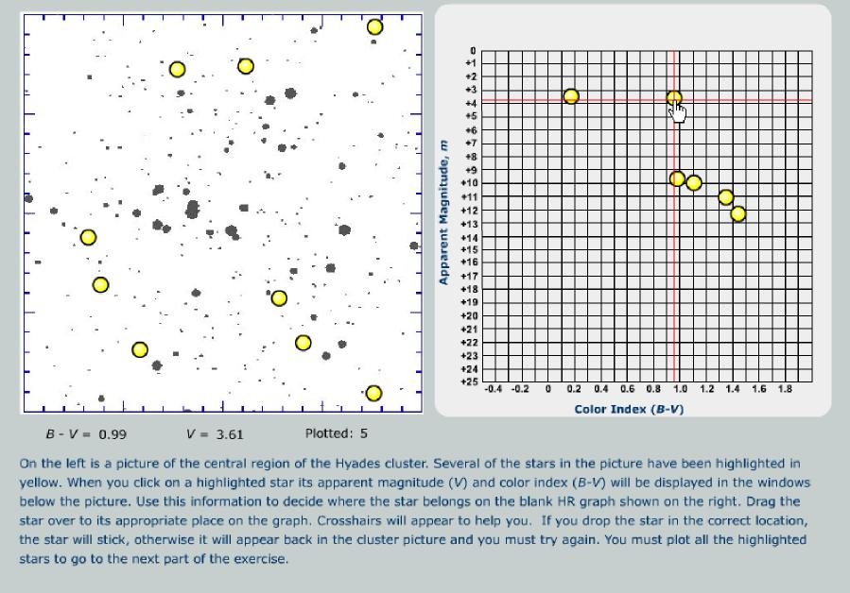
Figure 11.1 Portion of an exercise in VLab 11 where students place stars from the Hyades Cluster (left) on an HR diagram (right) using apparent magnitudes within the cluster. As students mouse down on the stars highlighted by yellow in the cluster on the left, the color index and visual magnitude appear below the left-side figure. Students then drag the star to the appropriate position on the HR diagram and release it, where it will remain if the position was chosen correctly and return to the cluster otherwise. In the example above, a student is about to position a star dragged from the cluster with B-V = 0.99 and V = 3.61 on the HR diagram. Once the HR diagram is constructed using all the stars marked in yellow, students use it in a second part of the exercise to determine the distance modulus and distance to the cluster (the technique is illustrated in Fig. 11.2).
Virtual Astronomy Laboratories 29
Virtual Astronomy Laboratories 30
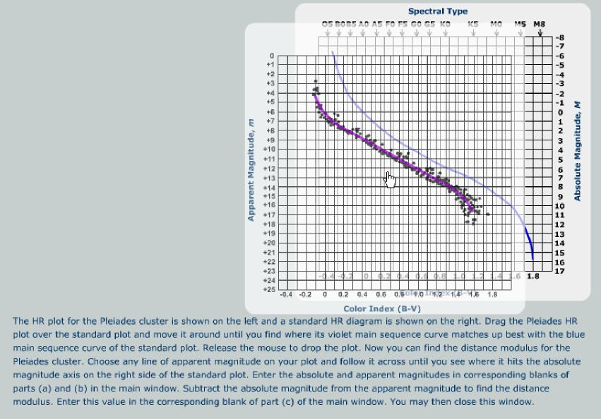
Figure 11.2 First portion of an exercise in VLab 11 where an HR diagram plotted using apparent magnitude is compared with a reference HR diagram in order to determine the distance modulus. The student is in the process of using the mouse to slide the actual HR diagram, plotted using apparent magnitude, over the reference diagram to find the best match for the main sequence. A comparison of the apparent and absolute magnitude scales on the two diagrams then yields the distance modulus.

VLab 12: Binary Stars
Virtual Astronomy Laboratories 31
This lab explores some basic properties of visual, eclipsing, and spectroscopic binary star systems.
- Introduction reviews binary star systems and how to determine the center of mass for such systems (see the center of mass graphical calculator in Fig. 12.1). Difficulty: Beginner.
- Visual Binaries uses the Sirius binary system to illustrate how Kepler’s laws and observation of the location for the center of mass may be used to determine both the total mass of the binary and the division of this mass between the two stars. Difficulty: Intermediate/Advanced.
- Eclipsing Binaries uses a simulation of the Algol system to illustrate how Kepler’s laws and the light curve may be used to analyze eclipsing binary systems (see Fig 12.2). Difficulty: Intermediate/Advanced.
- Spectroscopic Binaries illustrates how periodic doubling or shifting of spectral lines may be used to discover that a system is binary, and how to use that information to extract mass information about the system. Difficulty: intermediate/Advanced.
Learning Objectives: Students completing this laboratory should have a basic understanding of how mass information may be extracted from visual, eclipsing, and spectroscopic binary systems.
Dependencies on other Labs: VLab 8 for Kepler’s laws and related analysis of extrasolar planetary systems.
Conceptual Track: Sections 1 and 2, but 2 will require some math. Intermediate Track: Sections 1 and two out of 2, 3, 4.
Full Lab Track: All sections.
Abbreviated Lab Track: Sections 1 and two out of 2, 3, 4.

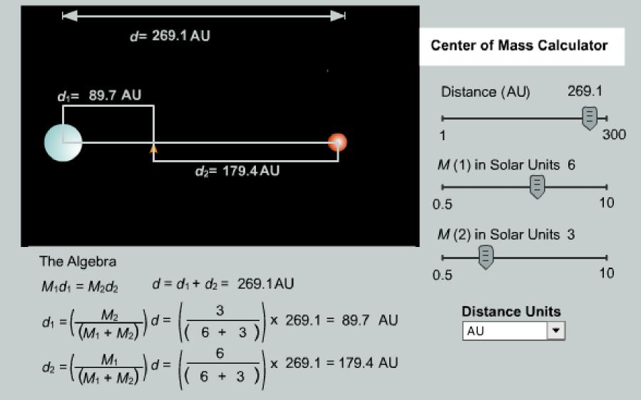
Figure 12.1 A center of mass calculator used in VLab 12. The location of the center of mass is updated graphically as the sliders are changed. Likewise, the values of variables in the algebraic equations are updated as the sliders change.
Virtual Astronomy Laboratories 32
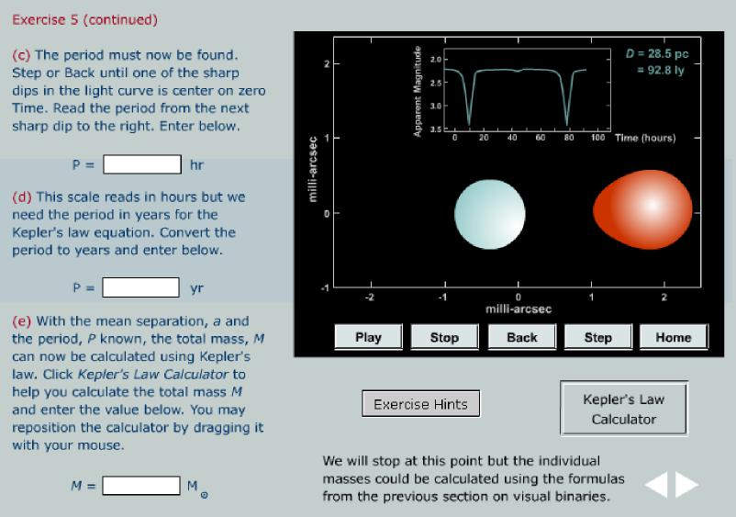
Figure 12.2 A portion of an exercise in VLab 12 where Kepler’s laws are used to infer the mass of the eclipsing binary.

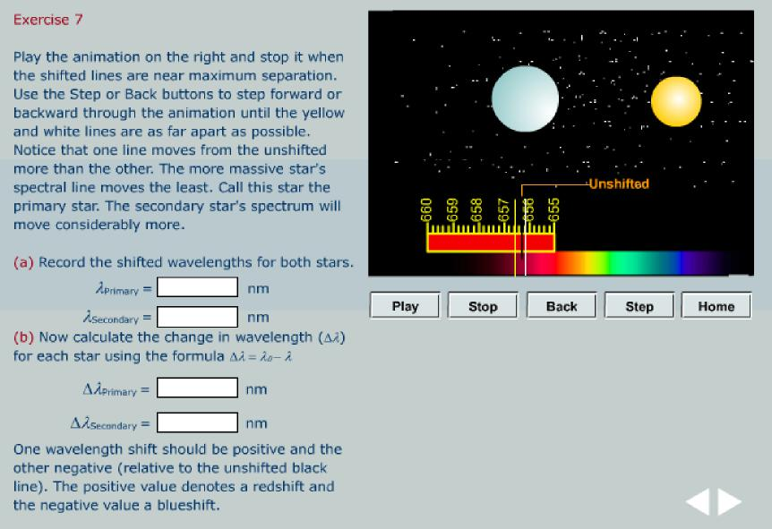
Figure 12.3 A portion of an exercise in VLab 12 illustrating the analysis of a spectroscopic binary to determine masses in the binary system.
Virtual Astronomy Laboratories 33

VLab 13: Stellar Explosions, Novae, and Supernovae
Virtual Astronomy Laboratories 34
Many stars undergo explosive events such as supernovae, novae, X-ray bursts, or gamma-ray bursts near the ends of their lives. This VLab discusses such explosive events and illustrates with exercises involving two specific examples: novae and Type Ia supernovae.
- White Dwarfs reviews the basic properties of white dwarfs, including the Chandrasekhar limiting mass. Difficulty: Beginner.
- Novae describes the binary star accretion processes that can lead to nova explosions (see Fig. 13.1). As part of this section, students are introduced to the general topic of explosive nucleosynthesis and element production through an element production simulator illustrating the evolution of isotope production with time in a nova explosion (see Fig. 13.2). Finally, (more ambitious) students are given access to a research-level element production code with Java graphical control interface and step-wise instructions that permits a realistic element-production calculation to be run with conditions controlled by the student (Fig. 13.3). Difficulty: the first portions are of Intermediate difficulty; Exercise 4 (the realistic element production calculation) is Advanced because it requires that students follow a (relatively simple) set of instructions exactly to set up and run the calculation. Although Exercise 4 requires attention to detail, the entire setup and simulation on a typical desktop computer should take no more than a few minutes.
- Type Ia Supernovae describes the mechanism leading to a Type Ia supernova. Students are introduced to the standard candle properties of this class of supernova through an exercise in which they use the observed light curve to determine the distance to SN 1994D (Fig. 13.4). Difficulty: Intermediate.
Learning Objectives: The overall goal is to introduce the general topic of stellar explosions and the element production that accompanies them. Students completing the lab should have a basic understanding of nova and Type Ia supernova explosions, of how such explosions create new elements, and of how Type Ia supernovae can be used to determine distances through their standard candle properties.
Dependencies on other Labs: VLab 12 is a useful companion because both novae and Type Ia supernovae involve accreting binary systems, but it is not essential.
Conceptual Track: Sections 1 and 3.
Intermediate Track: Sections 1—3, but omit Exercise 4 in Section 2.
Full Lab Track: All sections, but the instructor may wish to make Exercise 4 in Section 2 optional since it is a tamed but more technical project.
Abbreviated Lab Track: Sections 1—3, but omit Exercise 4 in Section 2.

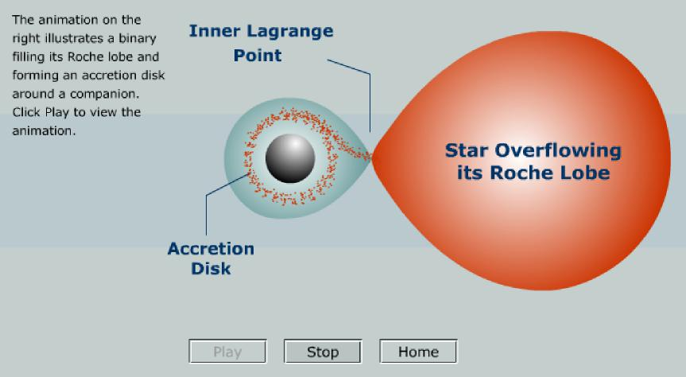
Figure 13.1 Animation from VLab 13 illustrating a star expanding to fill its Roche lobe and spilling over through the inner Lagrange point to form an accretion disk around a companion. (The binary system is assumed to be revolving counter-clockwise about the center of mass).
Virtual Astronomy Laboratories 35

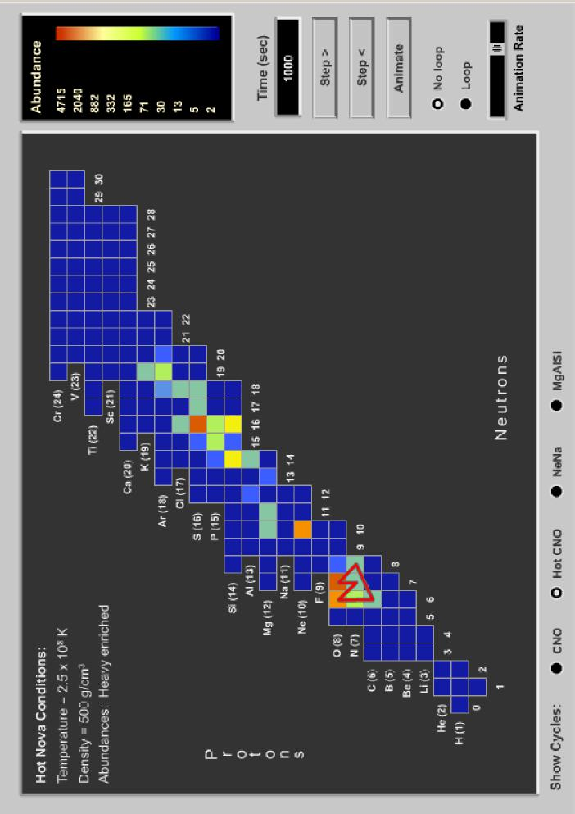
Figure 13.2 Nucleosynthesis simulator from VLab 13, illustrating element production in a nova explosion. Shown is a frame of an interactive animation that give the isotopic abundance pattern (see the relative abundance scale at the upper right) in the neutron— proton plane, 1000 seconds after initiation of a nova explosion. For simplicity in presentation and discussion, the temperature and density are assumed to be constant over this period. The initial white dwarf mass was assumed to be 1.3 solar masses and the white dwarf was assume to be enriched in heavy elements at its surface when the exposion was initiated. The hot-CNO cycle, which is largely responsible for powering the nova explosion, is indicated by the red closed lines (the check boxes at the bottom may be used to display such cycles). The results displayed in this animation were calculated using the element production program illustrated in Fig. 13.3.
Virtual Astronomy Laboratories 36

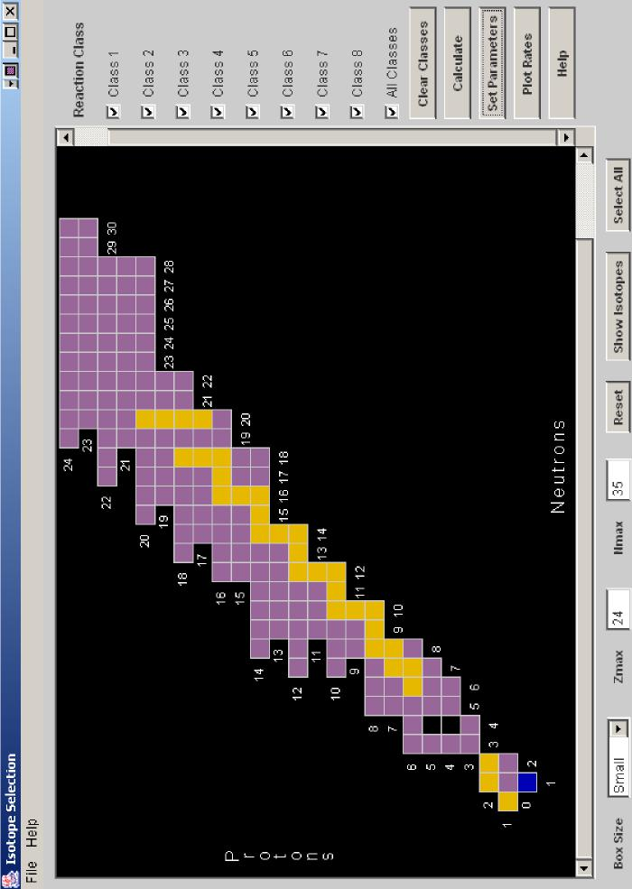
Figure 13.3 The control interface for an element production network code that is used in Exercise 4 of VLab 13. (Both the graphical user interface and the network solution algorithm are implemented as a Java applet, so this calculation runs on the client machine, not on the server.) This advanced exercise permits students to run a realistic simulation of element production on their own computer with conditions be chosen that are characteristic of explosive hydrogen burning in novae or X-ray bursts. The data for the simulation illustrated in Fig. 13.2 were calculated with this program. In the above illustration a calculation is being set up in which all possible nuclear reaction classes are to be included (the check boxes on the right). The isotopes to be included in the network are indicated in purple and those isotopes having non-zero initial abundance are indicated in yellow.
Virtual Astronomy Laboratories 37

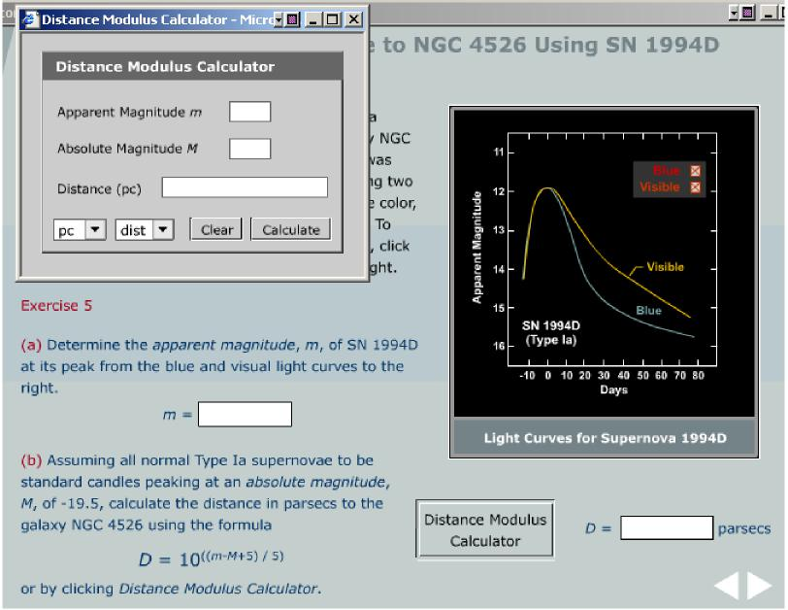
Figure 13.4 An exercise from VLab 13 in which students determine the distance to a Type Ia supernova by exploiting its standard candle properties. The secondary window that has been opened using the Distance Modulus Calculator button contains a tool used in a number of VLabs permitting any one of apparent magnitude, absolute magnitude, or distance to be calculated, given the other two.
Virtual Astronomy Laboratories 38

VLab 14: Neutron Stars and Pulsars
Virtual Astronomy Laboratories 39
This lab surveys basic characteristics of neutron stars and pulsars. Special emphasis is placed upon the period and period change of pulsars.
- Introduction motivates the study of pulsars as one of the three end states of stars. Difficulty: Beginner.
- Discovery focuses on the first pulsar detection by Bell and Hewish in 1967. The logic of why small periods indicate a small size for pulsars is explained.
Difficulty: Beginner.
- Properties of Neutron Stars explains the masses, sizes, and magnetic fields of neutron stars. The conservation of angular momentum and the lighthouse model are covered thoroughly. The Pulsar Explorer allows students to experiment with various pulsar parameters and view the result. Difficulty: Intermediate.
- Pulsar Periods emphasizes the period and period change as two of the most important parameters of a pulsar. The changes in period due to spin-down and glitches are covered. Students can actually measure a spin-down rate with the Pulsar Evolution Simulator (see Fig. 14-1). Difficulty: Intermediate.
- Distribution of Periods focuses on the P-Pdot diagram for 562 pulsars (see Fig. 14-2). Students are asked to interpret their Pulsar Evolution Simulator results using the diagram. Difficulty: Intermediate.
Learning Objectives: Students should have a good grasp of the characteristics of a pulsar and understand the special importance of period and the spin-down rate.
Dependencies on other Labs: None. Conceptual Track: Sections 1 - 3. Intermediate Track: Sections 1—4. Full Lab Track: All sections.
Abbreviated Lab Track: Sections 1—3.

Figure 14.1 This exercise allows students to measure the spin-down rate of a pulsar. They can measure the period of the pulsar at any time during a 30 year interval. The next page of this exercise provides a slope calculator in which they can enter two data points to find the spin-down rate.
Virtual Astronomy Laboratories 40
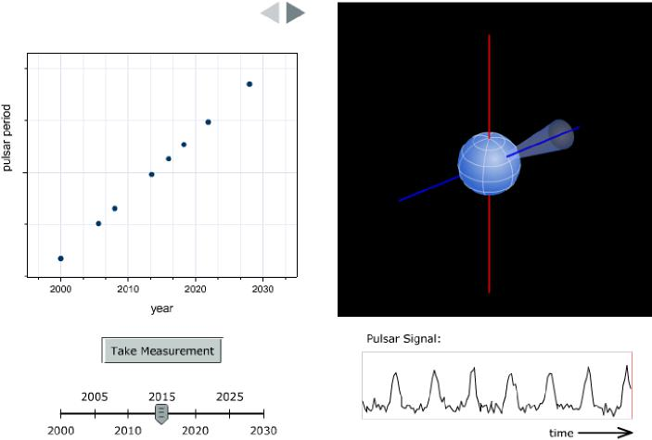
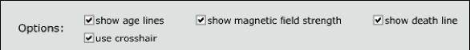
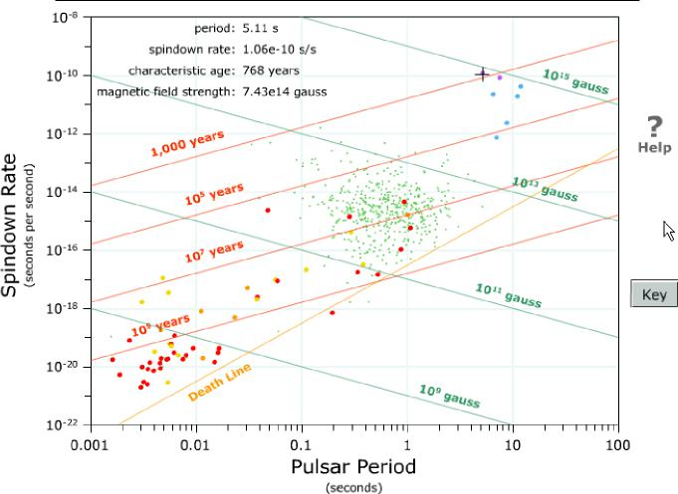
Figure 14.2 The P-Pdot diagram allows students to explore the range of values that exist for pulsar periods and spin-down rates. Different categories of pulsars are color-coded and students can read off their age and magnetic field strength.

VLab 15: General Relativity and Black Holes
Virtual Astronomy Laboratories 41
Virtual Astronomy Laboratories 42
- Introduction simply motivates that a star must “fight” gravity throughout its life. Black holes are the end states of stars where gravity has the most dramatic victory. Difficulty: Beginner.
- General Relativity looks at examples of gravity bending light that include the apparent positions of stars near the Sun during a solar eclipse and gravitational lensing of light from distant galaxies. The section concludes with an exercise where students use the angular size and redshift of an idealized Einstein ring to estimate the mass of the lensing object. Difficulty: Advanced.
- The Binary Pulsar discusses the creation of gravity waves where large masses are being accelerated. Students can investigate evolution of the binary pulsar over different timescales. Difficulty: Intermediate.
- The Nature of Black Holes explains terminology such as the photon sphere, event horizon, and Schwarzschild radius. Students can experiment with sending a light beam near a black hole (see Fig. 15.1) and calculate the Schwarzschild radius for different masses. Difficulty: Beginner.
- The Detection of Black Holes first discusses the difficulty involved before focusing on the detection of X-Rays from black hole accretion disks. Students work with simulated X-Ray data from a binary system where one member is a black hole. Techniques from variable star astronomy such as period searching (see Fig. 15.2) are applied to form the light curve of the system. Difficulty: Intermediate.
Learning Objectives: Students completing this laboratory should have a basic understanding of black holes.
Dependencies on other Labs: VLab 12 for basic familiarity with binary stars, VLab 14 for Pulsars.
Conceptual Track: 1-4.
Intermediate Track: All sections. Full Lab Track: All sections.
Abbreviated Lab Track: 1, 2, 4 and 5.
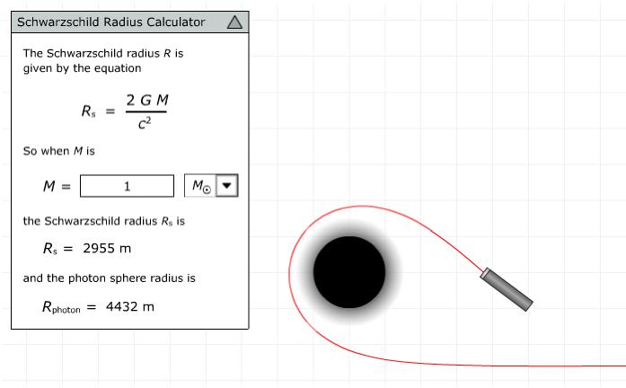
Figure 15.1 The Schwarzschild radius calculator allows students to calculate the Schwarzschild radius and the photon sphere radius for black holes of various masses and to experiment with a beam of light near a black hole.
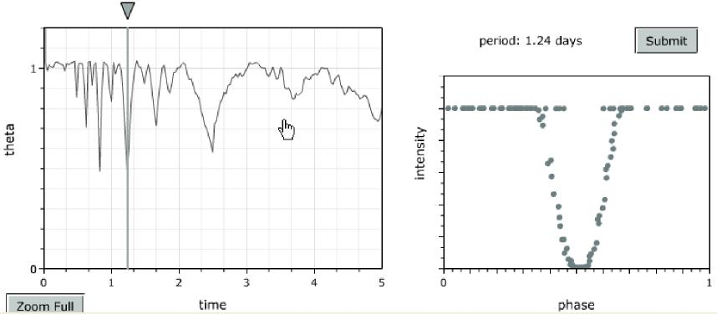
Figure 15.2 The left plot above show the results of a period search on photometry from the X-Ray binary. Theta is a statistical discriminant that should have a low value for the correct period. Students can form a light curves for any period (including the incorrect period shown here) by moving the gray triangle.

VLab 16: Astronomical Distance Scales
Virtual Astronomy Laboratories 43
Distances are crucial in astronomy. This VLab introduces the units used by astronomers to measure large distance (astronomical units, light years, and parsecs) and illustrates some methods (parallax and Cepheid variables) by which distances may be determined.
- The Astronomical Unit describes the use of the astronomical unit as a distance measure and the conversion between this and other distance units. Difficulty: Beginner.
- The Light Year defines the light year distance unit and the conversion between this and other distance units. Difficulty: Beginner.
- The Parsec describes the method of parallax (see Fig. 16.1), the associated natural distance unit of parsecs, and conversion between the parsec and other distance units. Difficulty: Intermediate.
- Cepheid Variables describes the use of variable stars to determine distances. It contains an exercise in which students retrieve a randomly selected Cepheid light curve from a Web address, determine its period, and use this information and the Cepheid period--luminosity relations to determine the distance to the star (see Fig. 16.2). Difficulty: Intermediate.
Learning Objectives: Students completing this laboratory should understand the basic distance units used in astronomy and how to convert between them, the method of parallax, and the method of using Cepheid period—luminosity relations to determine astronomical distances.
Dependencies on other Labs: VLab 1 for units conversion. Additional related material: VLabs 11 and 13 contain exercises illustrating other means of determining distances (see, for example, Fig. 13.4) and VLab 19 introduces the Hubble law and cosmological distance scales.
Conceptual Track: All sections. Intermediate Track: All sections. Full Lab Track: All sections. Abbreviated Lab Track: All sections.

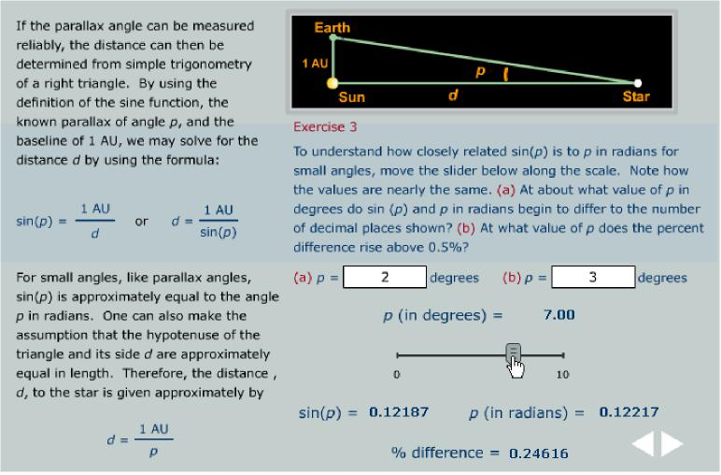
Figure 16.1 A portion of an exercise from VLab 16 introducing the method of parallax. In this part, students determine how good the small-angle approximation sin p ~ p is.
Virtual Astronomy Laboratories 44
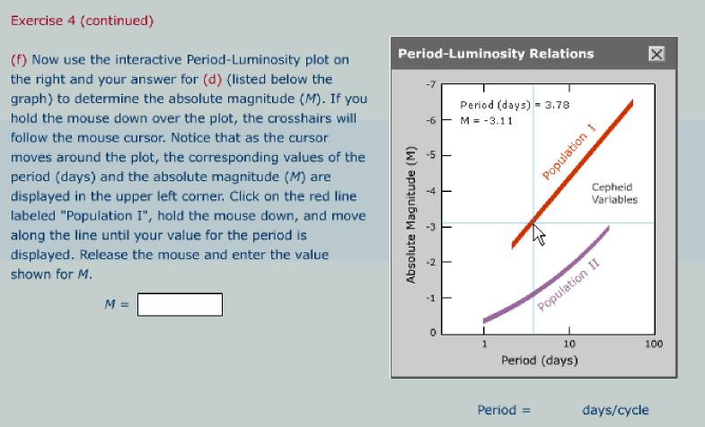
Figure 16.2 A portion of an exercise from VLab 16 in which students use the light curve for a Cepheid variable to determine the distance to the variable. In an earlier part of the exercise the student obtained a randomly selected light curve over the Web and determined the period for the variable. In this portion, the student is using the crosshair readout on the interactive period—luminosity graph to deduce the corresponding absolute magnitude. In the final portion of the exercise, the student will use the Distance Modulus Calculator displayed in Fig. 13.4 to relate the absolute magnitude found here and the apparent magnitude (given with the light curve) to determine the distance.

VLab 17: Evidence for Dark Matter
Virtual Astronomy Laboratories 45
There is strong evidence that the major fraction of the matter contained in the Universe does not interact significantly with normal matter, except through gravitation. This lab introduces the concept of such dark matter and explores two types of observations suggesting the existence of unseen matter in large amounts: galaxy rotation curves and gravitational lenses.
- Gravitational Constant describes converting the gravitational constant to a set of units that will be advantageous for the following exercises. Difficulty: Beginner/Intermediate.
- Cold Dark Matter in the Milky Way introduces the rotation curve for the Milky Way and the indication from it that there is a large amount of gravitating matter that is not visible in the galaxy. Through a systematic set of steps, students analyze the rotation curve of the Milky Way to finally determine the radial distribution of dark matter (See Figs. 17.1—17.2 below). Difficulty: Advanced.
- Gravitational Lenses introduces gravitational lensing through the analysis of a simple lens that exhibits two images (Figs. 17.3—17.4). Students are given the (randomly generated) angular position on the celestial sphere of the lens and the two images, and the redshifts for the lens and the source. They must then determine the angular separation of the images from the lens and the physical distance to the source and lens, and use this to determine the mass of the lens. Difficulty: Advanced.
Learning Objectives: Students completing this lab will have a quantitative understanding of how galaxy rotation curves and gravitational lensing may be used to determine the total mass in a region of space, and how both techniques suggest the presence of far more mass in the Universe than can be explained by the visible mass.
Dependencies on other Labs: VLab 1 for units conversion.
Conceptual Track: This lab consists primarily of two exercises that are advanced because they require some math to be done by hand and because they involve multiple steps. Therefore, there is no conceptual track for this lab that does not involve advanced exercises.
Intermediate Track: Either Sections 1—2 or Section 3. Full Lab Track: All sections.
Abbreviated Lab Track: Either Sections 1—2 or Section 3.

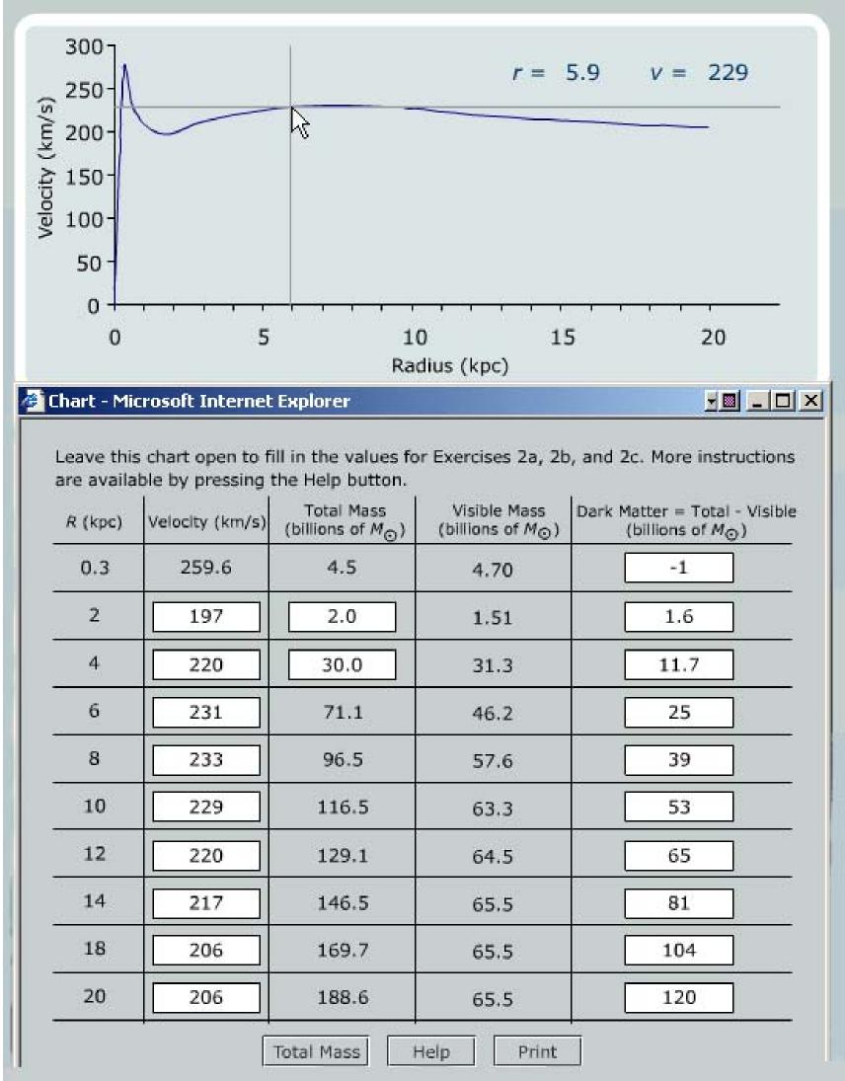
Figure 17.1 Initial steps of an exercise in VLab 17 to analyze the rotation curve of the Milky Way and determine the amount of dark matter contained with a 20 pc radius. In this step the student is filling out the table with rotational velocities (column 2) determined by using the crosshair readout for the velocity curve above the table.
Virtual Astronomy Laboratories 46

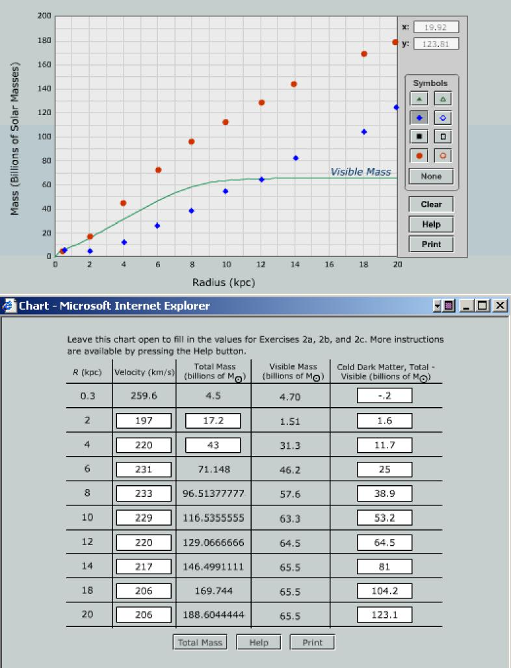
Figure 17.2 Conclusion of the VLab 17 exercise begun in Fig. 17.1. The student has followed a systematic set of instructions to complete the table and has used the Electronic Graph Paper tool (upper portion of the figure) to plot the total mass contained within a given radius (column 3 of the table and the red filled circles in the plot) and the amount of dark matter contained within that radius (column 5 of the table and the filled blue diamonds on the plot) for the Milky Way. Quantities within the white boxes in the table, and the red filled circles and blue filled diamonds on the plot, have been supplied by the student. The other quantities in the table and the solid Visible Mass curve were computed automatically for the student. This student has found that there is more enclosed dark matter than visible matter beyond a radius of about 12 pc.
Virtual Astronomy Laboratories 47

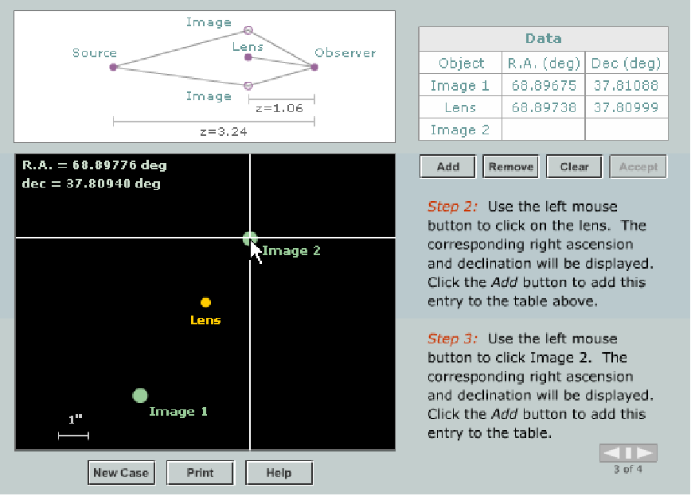
Figure 17.3 Initial steps of a VLab 17 exercise to determine the mass of a gravitational lens. The location of the lens and the two lensed images (labeled Image 1 and Image 2) of the source are shown in right ascension and declination on the celestial sphere in the lower left portion (these are selected randomly for each student). The schematic geometry is illustrated in the upper left. In the step illustrated above, the student is using the crosshairs to add angular positions of the lens and lensed images to the table in the upper right. This will then be used in subsequent steps to determine the angular separation between the lens and each of the lensed images.
Virtual Astronomy Laboratories 48

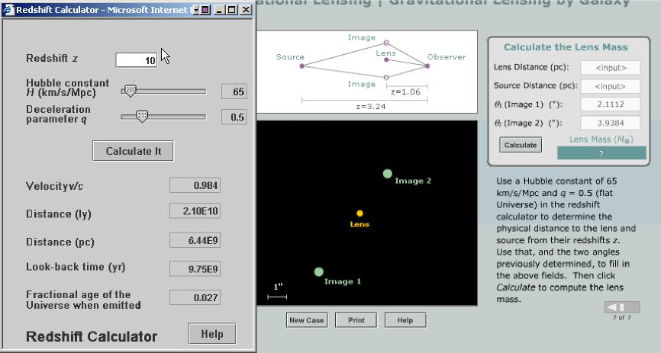
Figure 17.4 Conclusion of the VLab 17 exercise begun in Fig. 17.3. The angular separation of the images from the lens have been determined and entered in the table. The distances to the source and lens have been given to the student in terms of redshift. The Redshift Calculator tool on the left must be used to convert these redshifts to physical distance that are placed in the top two blanks of the table. Then pressing the Calculate button on the right will solve the lens equation (which was presented and explained in an earlier step) automatically for the mass of the lens. In this example, the redshift calculator assumes a cosmology with no vacuum energy and a closure density of matter to relate redshift to distance. A more general tool will be introduced in VLab 20 that incorporates user-specified values for the mass, radiation, and vacuum energy densities.
Virtual Astronomy Laboratories 49

VLab 18: Active Galactic Nuclei
Virtual Astronomy Laboratories 50
Dependencies on other Labs: Quasars are discussed further in VLab 19 in connection with cosmological redshifts and black holes are discussed further in VLab 15.
This VLab provides an introduction to the unified model of galaxies, active galaxies, and quasars: (1) Most galaxies (including our own) have supermassive black holes at their centers and these become central engines for active galaxies or quasars if matter feeds into them. (2) The detailed classification of an active galaxy or quasar (as a radio galaxy, Seyfert galaxy, ...) is largely a matter of the orientation of the central engine jets and accretion disk relative to the observer.
- Introduction provides a conceptual overview of the unified model of galaxies, active galaxies, and quasars. Difficulty: Beginner.
- Jets and Superluminal Motion introduces the idea that relativistic jets are expected to be a common property of active galaxies. Students are then led through an exercise concerning the optical jet of M87 that at first sight seems to contradict special relativity: they demonstrate for themselves that the apparent motion of knots in the jet on the celestial sphere seems to imply velocities greater than that of light (superluminal motion). See Fig. 18.1. Difficulty: Intermediate.
- Special Relativity reminds students of the basic premises of special relativity and then leads them through an exercise demonstrating that the apparent superluminal motion found in the preceding exercise is an illusion following directly from the principles of special relativity (see Fig. 18.2). Superluminal motion in the jets of active galaxies is then seen to be predicted by relativity, and their observation confirms the emission of relativistic jets by active galaxies and thus implies a powerful central engine in the active galaxy. Difficulty: Intermediate.
- Central Black Holes turns to the hypothesis that the central engine implied by the evidence from preceding sections is a rotating, supermassive black hole. Rather than discussing the evidence for supermassive black holes in distant active galaxies, we provide an exercise giving even more direct evidence for the unified model: observation of individual star motion at the center of the Milky Way. By simulating Keplerian motion of stars near the central radio source Sag A* and comparing with actual observations, students find that the center of our own galaxy harbors a 3 million solar mass object with a radius less than that of the Solar System and emitting little light. See Fig. 18.3. Difficulty: Intermediate.
Learning Objectives: Students completing this lab should have a basic understanding of the unified model of active galactic nuclei, quasars, and normal galaxies: that all or most galaxies harbor supermassive black holes at their center and that the observational properties of the galaxy then depends on whether matter is feeding into the black hole. They will have been introduced to two pieces of evidence supporting this picture: the observation of apparently superluminal jets for various active galaxies and quasars, and new very direct evidence of a supermassive black hole at the center of our own (not presently active) galaxy.

Conceptual Track: All sections. Intermediate Track: All sections. Full Lab Track: All sections. Abbreviated Lab Track: All sections.
Virtual Astronomy Laboratories 51
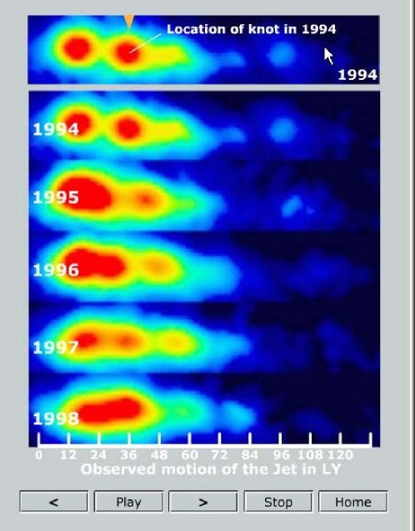
Figure 18.1 Portion of an exercise in VLab 18 where students demonstrate that the optical jet in M87 exhibits apparent superluminal motion.

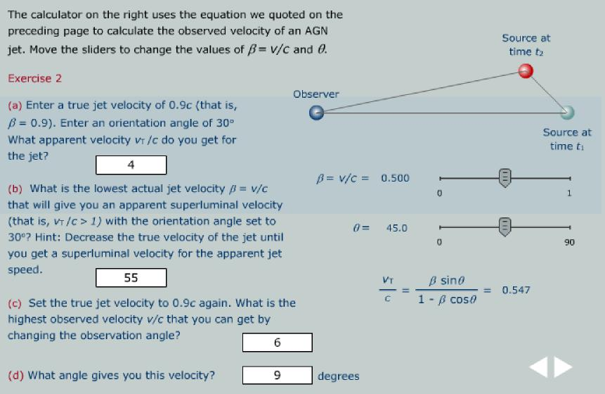
Figure 18.2 Portion of an exercise in VLab 18 where students use the principles of special relativity (specifically, Lorentz transformations incorporated into the calculator on the right side) to demonstrate that the apparent superluminal motion found in the exercise of Fig. 18.1 is an illusion caused by special relativity. Thus students find that the true jet velocity is never greater than c.
Virtual Astronomy Laboratories 52

Figure 18.3 Exercise from VLab 18 in which students construct Kepler orbits for stars in orbit around the radio source Sag A* at the center of the Milky Way. In the exercise, students are given the orbital parameters for two observed stars (S0-2 in the nearly vertical orbit and S0-16 in the horizontal orbit). They then use the orbit builder tool to construct these orbits around the central mass, animate the orbits, and adjust the mass of the central object until the observed periods for the two stars are reproduced by the simulation, thus determining the central mass (a little more than 3 million solar masses). For simplicity in presentation, the highly elliptical orbits of the two stars are assumed to lie in the same plane. This is not true but does not influence the results of the exercise since the period is independent of the orientation. The orbit builder tool is a general purpose Kepler orbit animator that allows the user to build any gravitating system of objects in orbit around a central object. An instructor may thus use this tool to construct a number of other exercises that go beyond the specific ones given in this example. In VLab 8, we used the same orbit builder tool to construct a fictitious solar system involving some extrasolar planets and some planets from our Solar System in orbit around the same star, for example. Click the Help button on the bottom row of buttons for a detailed description of how to use the orbit builder tool.
Virtual Astronomy Laboratories 53
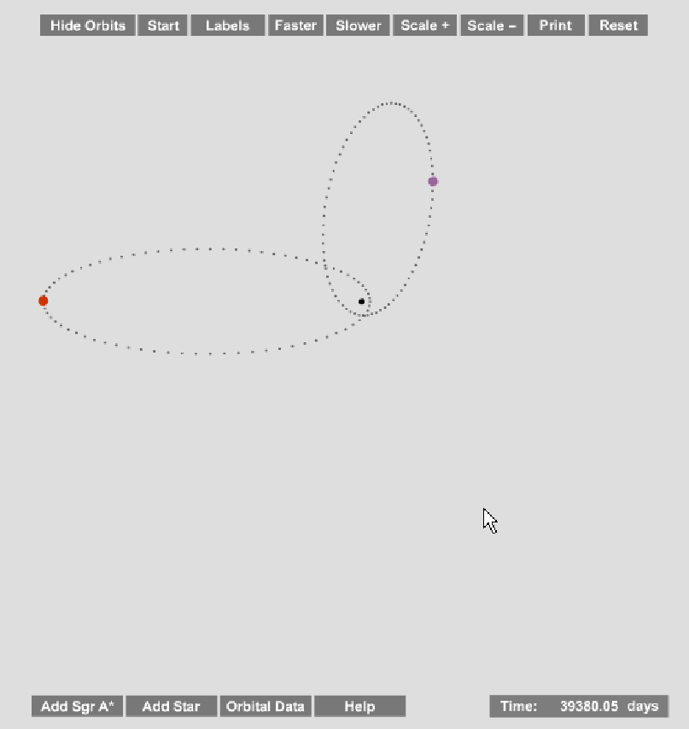

VLab 19: The Hubble Law
Virtual Astronomy Laboratories 54
The fundamental paradigm of modern cosmology is that we live in an expanding universe. This VLab investigates the aspects of that expansion that are described by Hubble’s law. (Deviations from the Hubble law will be addressed in VLab 20.)
- Introduction introduces redshifts, the evidence for expansion, Hubble’s law and Hubble’s constant, and the units for Hubble’s constant. Difficulty: Beginner.
- Quasars and Hubble’s Law introduces the basic properties of quasars and leads students through excercises in which the redshifts are determined for several quasars by interactive comparison of shifted and unshifted spectral lines (see Fig. 19.1). These redshifts are then used in conjunction with Hubble’s law to estimate the distance to the quasars. Difficulty: Intermediate.
- Expansion of the Universe explores the nature of the Hubble expansion by investigating the uniform expansion of a two-dimensional space. Students control the expansion of the space (see Fig. 19.2), demonstrate that the expansion follows a Hubble law and extract the corresponding Hubble constant (Fig. 19.3), and then demonstrate that any observer in any galaxy will see themselves as the center of the expansion and extract the same Hubble law (Fig. 19.4). Difficulty: Intermediate.
Learning Objectives: Students completing this VLab should have a basic understanding of the Hubble law, of how redshifts are determined from the shift of spectral lines and used in conjunction with Hubble’s law to estimate distances, and of the critical conceptual issue that the expansion is not a result of (peculiar) velocities within space, but rather of the expansion of space itself. As a consequence, students should grasp more clearly why there is no center of the expansion and why any observer in any galaxy has the illusion of being the center of the expansion.
Dependencies on other Labs: VLab 20 is an important complement to this VLab because it introduces deviations from the Hubble law caused by matter, radiation, and vacuum energy densities.
Conceptual Track: Sections 1—3. Intermediate Track: Sections 1—3. Full Lab Track: All sections.
Abbreviated Lab Track: All sections.

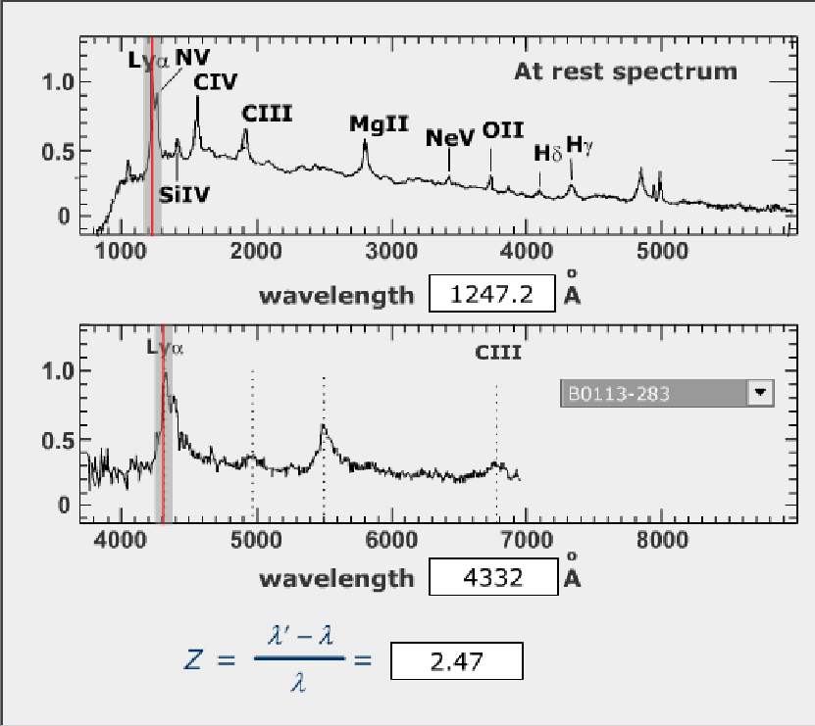
Figure 19.1 Quasar redshift exercise from VLab 19. The student is determining the redshift for a quasar spectrum by comparing the frequency for a spectral line (Lymann alpha in this case) to that for a spectrum taken at rest. Different quasars may be selected using the dropdown menu on the right of the bottom spectrum.
Virtual Astronomy Laboratories 55

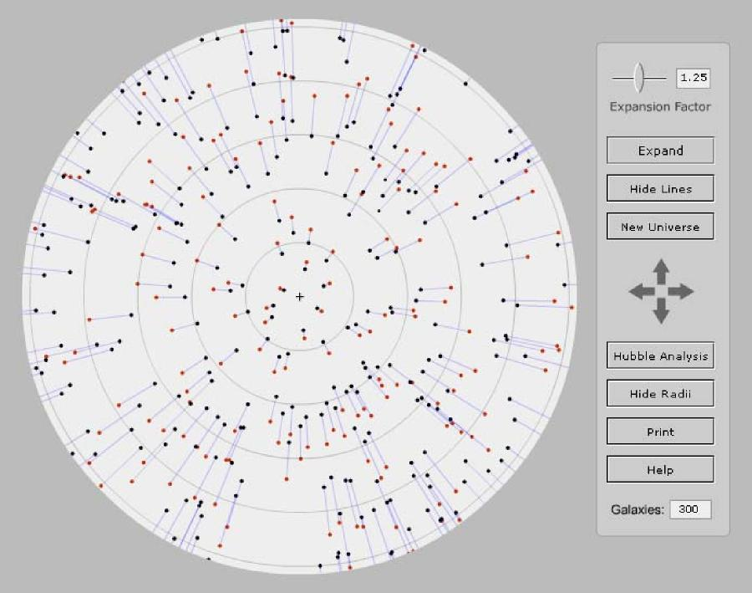
Figure 19.2 The Hubble expander laboratory from VLab 19 permits the properties of a two-dimensional uniformly expanding space to be explored. The observer is assumed to be located at the + sign at the center of the display. The student chooses an expansion factor using the top slider and expands this two-dimensional universe uniformly by clicking Expand. Clicking Show Lines connects the position of each galaxy before and after the expansion with a line (black dots denote the position of the galaxy before expansion; red dots denote the position afterward), which makes it clear that the expansion appears to be centered on the observer at the + sign (but see Fig. 19.4 below). Further, the distance between shifted and unshifted galaxies increases with distance from the observer, suggesting that the expansion in this space may be obeying a Hubble law. The student is asked to check this by clicking the Hubble Analysis button and carrying out the Hubble law analysis on these galaxies described in Fig. 19.3 below.
Virtual Astronomy Laboratories 56

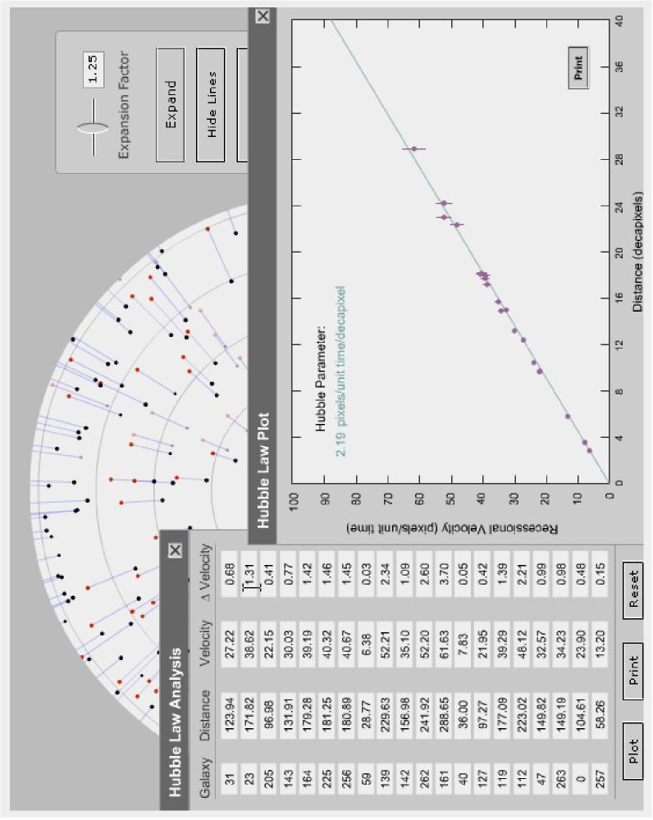
Figure 19.3 Test of whether the two-dimensional expanding space of the Hubble expander laboratory from VLab 19 obeys a Hubble law, and determination of the corresponding Hubble parameter. Students fill the table with distances and velocities by selecting either the shifted (red) or unshifted (black) points for galaxy pairs using the mouse. A simulated experimental uncertainty in the velocity is also inserted (column 4 of the table). Once the table is filled with data, clicking the Plot button produces the Hubble law plot with a straight-line fit determining the Hubble parameter for the space. In the simulation we use 10 pixels on the screen (a decapixel) as the standard distance unit and the time for the expansion in the simulation as the standard time unit. Thus, we quote the Hubble parameter in units of pixels/unit time/decapixel, which mimics the somewhat unusual units of km/s/Mpc commonly used for the actual Hubble parameter.
Virtual Astronomy Laboratories 57

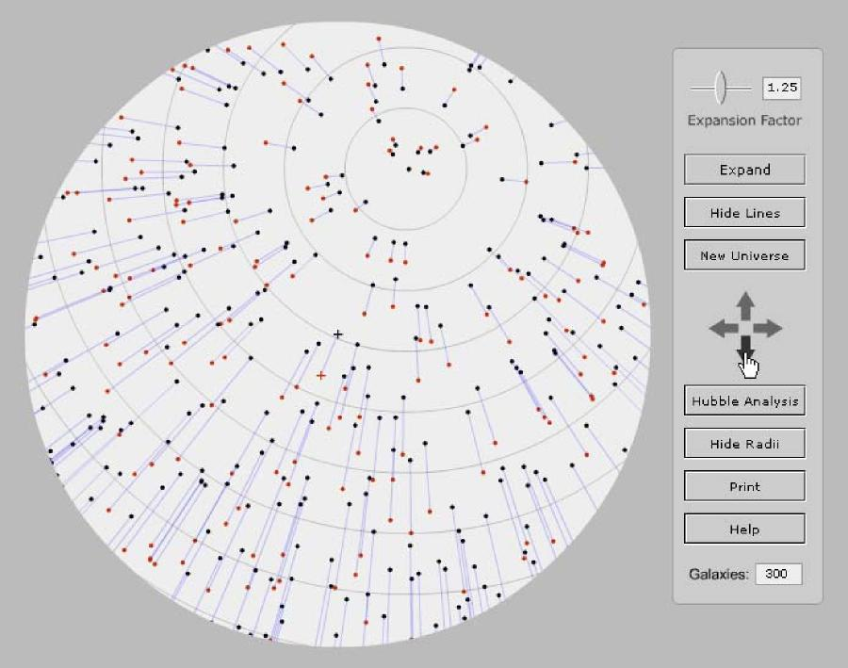
Figure 19.4 Explicit demonstration that any observer will think themselves to be the center of the expansion in the uniformly expanding two-dimensional space of the Hubble expander laboratory in VLab 19. This diagram differs from the one in Fig. 19.2 in that the student has been asked to assume that the observer is no longer at the + symbol in the center of the plot, but is rather on one of the other galaxies. The student shifts the pattern using the arrow keys on the right side until the shifted and unshifted positions of the chosen galaxy coincide (that is, the observer on the new galaxy has defined a coordinate system in which he is at rest.) As the diagram illustrated above indicates, all galaxies now appear to be receding from the new observer with a velocity increasing with distance. Students are then invited to perform the Hubble law analysis depicted in Fig. 19.3 again, with velocities and distances now measured with respect to this new observer. They then find, within the undertainty implied by the simulated error bars on the data, that the Hubble law is still obeyed with the same Hubble constant. Students are then asked to speculate in an essay question about what this means for the nature of the Hubble expansion. One hopes that the answer will invoke the idea that the Hubble law is a global law that applies to the expanding spacetime itself, not just for any one observer.
Virtual Astronomy Laboratories 58

VLab 20: Fate of the Universe
Virtual Astronomy Laboratories 59
VLab 19 introduced the Hubble law for the expansion of the Universe. But the evolution of the actual Universe must be more complex than Hubble law evolution because the Universe contains both relativistic and non-relativistic energy density that alters the rate of the expansion with time. In addition, if the cosmological constant is not zero, the expansion will be influenced by a vacuum energy density. In this VLab we introduce a tool that is capable of accounting for all of these factors at the same time (by numerical integration of the Friedmann equations). This entire lab will explore the consequences for the past history and ultimate fate of the Universe based on the relative contributions of non-relativistic particles (which we shall term matter), relativistic particles (which we shall term radiation), and vacuum energy density (that is, a cosmological constant) to the evolution of the cosmic scale factor. We shall place particular emphasis on the implications of the new constraints on cosmology coming from high-redshift supernovae and cosmic microwave background anistropies.
- Introduction defines cosmology and introduces the concepts of spatial curvature, that gravity is geometry, and the cosmic scale factor. Difficulty: Beginner.
- The Cosmological Constant introduces the cosmological constant in historical perspective and raises the possibility that it is not zero. It then repeats an exercise from VLab 13 demonstrating the use of Type Ia supernovae as standard candles to explore the Universe at high redshift. Evidence is then cited that such supernova data suggest that the cosmological constant is not zero. Difficulty: Intermediate.
- The Fate of the Universe describes general evolutionary histories for the scale factor, first for a Universe with no cosmological constant and then for one with a finite cosmological constant. The idea of a critical density and its relationship to a flat spatial geometry is introduced, first for a Universe with no cosmological constant and then generalized to include density contributions from matter, radiation, and vacuum energy. Difficulty: Intermediate.
- Expansion History introduces the expansion history tool (a numerical Friedmann solver; see Fig. 20.1) and guides the student through a series of virtual experiments in which the influence of a variety of factors on evolution of the cosmic scale factor is investigated. Among the virtual experiments carried out are
- Evolution of the scale factor for zero mass, radiation, and vacuum energy density (that is, by the Hubble law) but for different values of the Hubble constant (see Fig. 20.2).
- Evolution of the scale factor for different matter densities in a matter-only Universe (see Fig. 20.3).
- Evolution of the scale factor for different radiation energy densities in a radiation only Universe.
- Evolution of the scale factor for different vacuum energy densities in a vacuum energy only Universe (see Fig. 20.4).

- Evolution of the scale factor for a Universe with critical density (Ω = 1) evenly divided among radiation, matter, and vacuum energy.
Virtual Astronomy Laboratories 60
- Evolution of the scale factor for a Universe having the best current cosmological parameters (a Hubble constant of about 72 km/s/Mpc and Ω = 1 with 30% coming from matter and 70% from vacuum energy). See Fig. 20.5.
Difficulty: Intermediate/Advanced
5. CMB Anisotropies is conceptual, describing recent results from WMAP and related observations, and high-redshift supernovae, to motivate the choice of cosmological parameters used in the exercises of the preceding section. Difficulty: Beginner.
Learning Objectives: By a series of hands-on experiments evolving the Universe with different values of the Hubble parameter, mass density, radiation density, and vacuum energy density, the student should gain an understanding of how these parameters govern the past, present, and future of the Universe. By associating these hands-on experiments with the newest observations from WMAP and high-redshift supernovae, the student should begin to appreciate the growing evidence that we live in a Universe dominated by vacuum energy density and mass density, with the role of vacuum energy density increasing steadily as the Universe expands forever.
Dependencies on other Labs: VLab 19 is a suggested precursor to this lab since VLab 19 introduces the basic Hubble law.
Conceptual Track: All section. Intermediate Track: All sections.
Full Lab Track: All sections, though the instructor may choose to omit one or two of the closely-related Exercises 2—7.
Abbreviated Lab Track: All sections but omit Exercise 1 (which is repeated from VLab 13) and several of the closely-related Exercises 2—7.

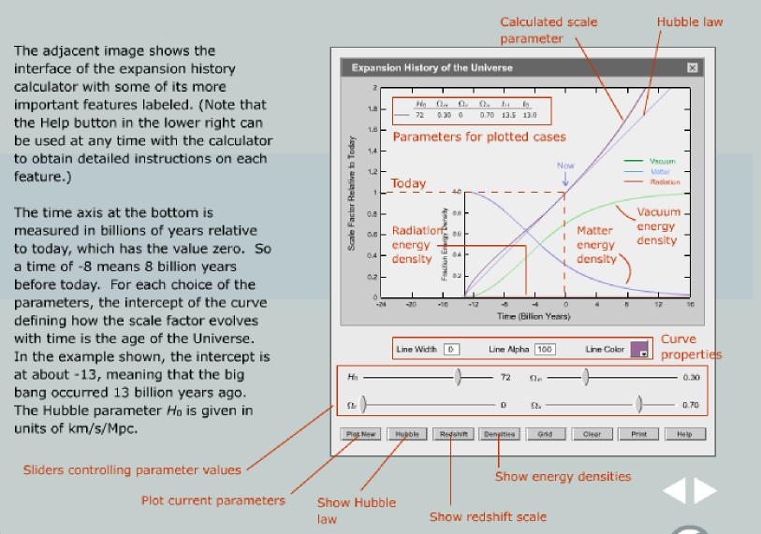
Figure 20.1 An overview page from VLab 20 illustrating various features of the expansion history calculator (Friedmann solver).
Virtual Astronomy Laboratories 61
Figure 20.2 Portion of a virtual experiment from VLab 20 in which students use the Friedmann solver to determine the age of the Universe and the time corresponding to a redshift of z = 1 for a pure Hubble law Universe (no matter, radiation, or vacuum energy density) with different values of the Hubble parameter. The student has used the solver on the left to compute the history of the scale factor as a function of time for three different sets of parameter values and is filling in the table on the right with quantities determined from the calculations displayed on the left (notice the Examples shown above the table).
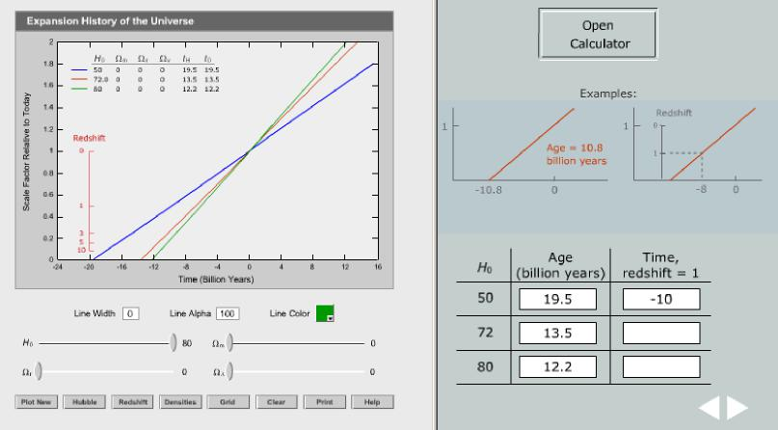

Figure 20.3 Portion of a virtual experiment from VLab 20 in which students use the Friedmann solver to determine the evolution of a pure matter Universe. The student has used the solver on the left to compute the history of the scale factor as a function of time for four different matter densities and is filling in the table on the right with quantities determined from the calculations displayed on the left.
Virtual Astronomy Laboratories 62
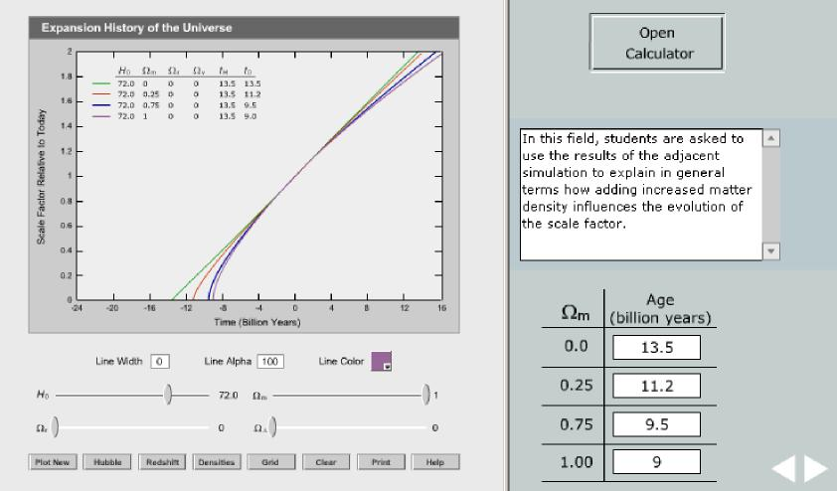
Figure 20.4 Portion of a virtual experiment from VLab 20 in which students use the Friedmann solver to determine the evolution of a pure vacuum energy Universe. The student has used the solver on the left to compute the history of the scale factor as a function of time for four different vacuum energy densities and is filling in the table on the right with quantities determined from the calculations displayed on the left.
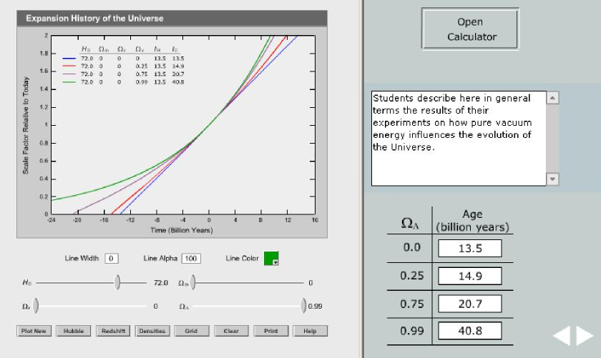

Figure 20.5 Portion of a virtual experiment from VLab 20 in which students use the Friedmann solver to determine the evolution of a Universe having parameters consistent with the most recent cosmological observations (flat geometry with Ω = 1 consisting of 70% vacuum energy, 30% mass, and negligible radiation). The student has used the solver on the left to compute the history of the scale factor as a function of time for these parameters and an assumed Hubble constant of 72 km/s/Mpc. In addition, by clicking the Densities button, the evolution of the matter, radiation, and vacuum energy densities as a function of time have been displayed (the radiation density, shown in red, is zero for the entire history on the resolution of the timescale plotted here). In this exercise, the student has been asked to answer two questions: to explain in terms of the evolution of energy densities the shape of the scale factor curve (e.g. matter domination switching to vacuum energy domination) and to estimate how long ago it was when the vacuum energy began to exceed the matter contribution in the evolution of the Universe.
Virtual Astronomy Laboratories 63
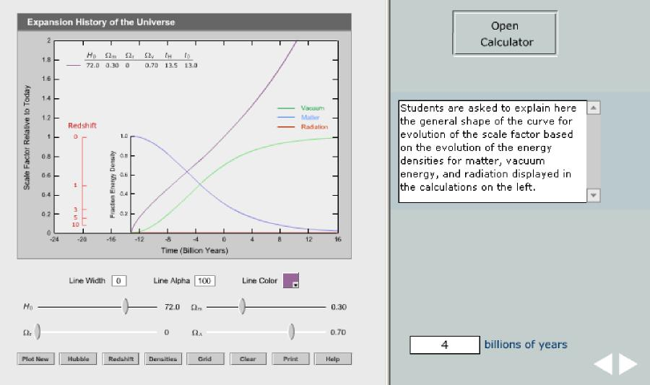

Appendix A
Virtual Astronomy Laboratories 64
