For Adjunct Instructors:
When things go wrong – and students need more from us…
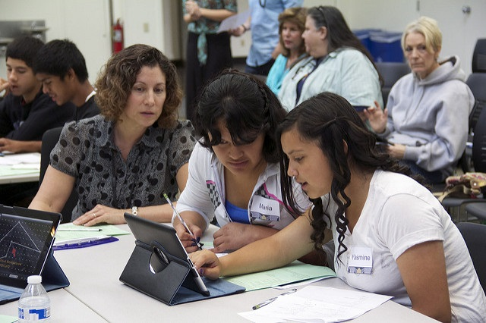
Carol A. Kelly
MEd Program in Library Media Studies
Experience: 30 years as adjunct instructor at Salem State
40 Years as a K-12 School Librarian/Technology Director

We may be the most useful connection that our students make.
As adjunct instructors we are often not as embedded in the life of Salem State as full-time, tenure track instructors. We may seldom actually see our colleagues if we teach online. We often don’t have an office which would allow us to mingle and chat with peers as well as students. With luck, we’re a member of a welcoming department where we have the opportunity to identify mentors or form connections with full-time faculty.
Despite our part-time nature and the semester-to-semester uncertainty, many of the connections that full-time faculty and adjunct faculty make with students are the same. We teach our students, we comment on their work, we have conversations with them and we may be the person whom they feel they can trust and confide in.
Many SSU students are first in their family to attend college. They don’t have a backlog of siblings or cousins or parents who’ve gone through the experience, who understand the pressures and difficulties. Some of our students are experiencing their first time away from home. All the problems that entails can distract from our students’ ability to be their best student selves – things like self-organizing, resisting social temptations when work needs to be done, managing budgets and getting along with roommates. Students may have undiagnosed disabilities, language difficulties, anxiety and a host of other problems. We need to know where to go for help – and SSU offers a great set of resources. It’s just hard sometimes to find what you need when you need it.
Each of the documents in this module focuses on a single sort of problems that students might have. The idea is that this quick, sorted list will make your life easier and help you put the student in contact with what they need.
In addition, there are resources for you as a teacher who may – heaven help us with AI – find students have violated academic integrity. We like to think this mainly happens through ignorance on their part, but we know that students, with something due that they can’t manage, may panic, send in someone else’s work or simply download from the internet. SSU’s policy is remarkably humane and puts a serious but forgiving spin on the first instance of violation of academic integrity but gives us the power to deal with students who choose to do it more often. Also in this list is the process for reporting a student at risk. Retention of students is an important value of SSU but that does not mean you need to pass a student whose work is not acceptable. The Student at Risk process marshals support as well as offers realistic responses to student failure.

